Software Requirements Specification (SRS)

***AI-Driven Job Matching Platform for Palestine***

## Document Control

|  |  |
| --- | --- |
| **Document Information** | |
| **Title** | Software Requirements Specification for AI- Driven Job Matching Platform |
| **Date** | May 19th, 2025 |
| **Status** | Draft |
| **Version** | 1.0 |
| **Prepared for** | Ministry of Labor (MoL), Palestinian Employment Fund (PEF) and Enabel. |
| **Reference** | SRS_AI_JMP_V1.0_ May_2025 |

***Disclaimer:***

*This document is provided for informational purposes as part of a public call for proposals. While it may be shared publicly, it remains the intellectual property of Belgian agency for international cooperation (Enabel) and the Palestinian Ministry of Labour (MoL). Unauthorized modification, distribution or misrepresentation is prohibited.*

**Table of Contents**

1. Introduction 6
   1. Purpose 6
   2. Document Conventions 6
   3. Intended Audience 6
   4. Project Scope 7
   5. References 8
2. Overall Description 8
   1. Product Perspective 8
   2. Product Functions 8
   3. User Classes, Characteristics, and Nees 9
   4. Operating Environment 10
   5. Design and Implementation Constraints 11
   6. User Documentation 11
   7. Assumptions and Dependencies 12
3. System Features and Functional Requirements 13
   1. User Management and Authentication 13
      1. Job Seeker Registration and Profile Management 13
      2. Employer Registration and Profile Management 14
      3. Third-Party Job Portals Registration and Integration (i.e. jobs.ps) 14
      4. Administrator User Management 15
      5. Authentication and Authorization 16
   2. Job Posting and Management 16
      1. Job Creation and Publishing 16
      2. Job Search and Filtering 17
      3. Job Interaction Process 17
      4. Job Status Tracking 18
   3. AI-Driven Matching System 18
      1. A Vector-Based (Skills-Based and Behavior) Matching Algorithms 18
      2. Job Recommendation Engine 19
      3. Candidate Recommendation for Employers 19
   4. Integration with External Systems 19
      1. External Job Site Integration 19
      2. Government Database Integration 20
      3. API Framework 20
   5. Reporting and Analytics 20
      1. User Activity Monitoring 20
      2. Employment Statistics 21
      3. System Performance Metrics 21
      4. Custom Report Generation 21
   6. Notification System 22
      1. Email Notifications 22
      2. In-App Notifications 22
      3. SMS Notifications 22
   7. Content Management 23
      1. News and Updates 23
      2. FAQ and Help Center 23
4. External Interface Requirements 24
   1. User Interfaces 24
   2. Hardware Interfaces 25
   3. Software Interfaces 25
   4. Communications Interfaces 26
5. Non-Functional Requirements 27
   1. Performance Requirements 27
      1. Response Time 27
      2. Throughput 27
      3. Resource Utilization 27
      4. Scalability 28
   2. Security Requirements 28
      1. Authentication and Authorization 28
      2. Data Protection 28
      3. Privacy and Compliance 29
      4. Security Monitoring and Incident Response 29
   3. Reliability and Availability 29
      1. Availability 29
      2. Fault Tolerance 30
      3. Disaster Recovery 30
      4. Error Handling 30
   4. Usability and Accessibility 31
      1. User Interface 31
      2. Accessibility 31
      3. Multilingual Support 31
      4. User Experience 32
   5. Maintainability and Portability 32
      1. Maintainability 32
      2. Portability 32
      3. Compatibility 33
   6. Legal and Compliance Requirements 33
      1. Regulatory Compliance 33
      2. Intellectual Property 33
      3. Service Level Agreements 33
   7. Operational Requirements 34
      1. Monitoring and Logging 34
      2. Backup and Recovery 34
      3. System Administration 34
      4. Documentation 34
   8. Cultural and Political Requirements 35
      1. Cultural Considerations 35
      2. Political Considerations 35
6. Other Requirements 36
   1. Data Migration 36
   2. Internationalization Requirements 36
   3. Training Requirements 36
   4. Appendix A: Analysis Models 38
   5. Appendix B: Issues List 50

**Glossary**

|  |  |
| --- | --- |
| **Term** | **Definition** |
| AI | Artificial Intelligence |
| API | Application Programming Interface |
| GDPR | General Data Protection Regulation |
| LMIS | Labor Market Information System |
| MoL | Ministry of Labor |
| Enabel | Belgian agency for international cooperation |
| NLP | Natural Language Processing |
| PEF | Palestinian Employment Fund |
| RBAC | Role-Based Access Control |
| RTO | Recovery Time Objective |
| RPO | Recovery Point Objective |
| SLA | Service Level Agreement |
| SRS | System Requirements Specification |
| ToR | Terms of Reference |
| WCAG | Web Content Accessibility Guidelines |
| YEP | Youth Economic Empowerment in Palestine |

# Introduction

# Purpose

This Software Requirements Specification (SRS) document provides a comprehensive description of the AI-Driven Job Matching Platform to be developed for the Ministry of Labor (MoL) and Palestinian Employment Fund (PEF) in Palestine. The document details the functional and non- functional requirements for the platform, which aims to enhance labor market efficiency by providing real-time data integration, standardizing job postings, and facilitating employment for job seekers.

This SRS will serve as the foundation for the subsequent system design and development phases, ensuring that all stakeholders have a clear understanding of what the system will do and how it will operate. It will also form the basis for the Terms of Reference (ToR) for the Phase Two procurement process for system implementation.

# Document Conventions

This document follows these conventions:

|  |  |
| --- | --- |
| **Term** | **Description** |
| **SHALL** | Refers to a mandatory requirement that must be fulfilled during Phase 1 of platform development. The vendor/developer is required to cover this feature in the current implementation phase. |
| **SHOULD** | Indicates a requirement that will take place in phase 2 and the developer should take it into consideration for future scalability. |
| **MAY** | Refers to a requirement anticipated for Phase 3 or subsequent phases. The developer is encouraged to consider this requirement generally, keeping future scalability in mind. |
| **TBD** | To Be Determined, indicates information that is not yet available but will be provided in future versions |
| **Note** | Provides additional information or clarification |

Requirements are categorized as follows:

|  |  |
| --- | --- |
| **Requirement Number** | **Description** |
| FR-XX | Functional Requirements |
| NFR-XX | Non-Functional Requirements |
| IR-XX | Interface Requirements |
| DR-XX | Data Requirements |
| SR-XX | Security Requirements |

# Intended Audience

This document is intended for the following stakeholders:

|  |  |
| --- | --- |
| **Stakeholder** | **Role** |
| Ministry of Labor (MoL) | Officials who will review and approve the requirements and solution owner. |

|  |  |
| --- | --- |
| Palestinian Employment Fund (PEF) | Officials who will review and approve the requirements |
| Enabel and its consultants | Donor, overseeing the project and approves requirements |
| Development team | Who will design and implement the system |
| Technical evaluators | Who will assess vendor proposals |
| System administrators | Who will maintain and support the system (mainly are the system administrators from the MoL) |
| Integration partners | Including job sites and other external systems |

# Project Scope

The AI-Driven Job Matching Platform is part of the "Youth Economic Empowerment in Palestine (YEP)" program, which aims to enhance Palestinian young people's employability and economic empowerment.

The platform will serve as the core component of the future Labor Market Information System (LMIS), integrating multiple job sources and government databases to optimize job matching, provide analytics, and support decision-making.

### In Scope

The platform will include the following key components:

* User Management System: Registration and profile management for job seekers, employers, external job sites, and administrators
* Job Posting Management System: Creation, publishing, and search for job opportunities
* AI-Driven Matching Engine: Skill-based matching algorithms using natural language processing, and recommender systems
* Integration Framework: APIs and adapters for connecting with external job sites and government databases
* Reporting and Analytics: Dashboards and reports for monitoring system performance and labor market trends Including (jobs posted, and users registered etc.)
* Security Framework: Authentication, authorization, and data protection mechanisms
* Multilingual Support: Full functionality in both Arabic and English
* Limited onboarding and testing sessions with internal stakeholders.

### Out of Scope

The following items are explicitly excluded from this phase of the project:

1. Implementation of the full Labor Market Information System (LMIS)
2. Hardware procurement for hosting the solution
3. Integration with systems beyond those specified in this document
4. Training of end-users (this will be addressed in Phase Two)
5. Long-term support and maintenance (to be addressed in separate agreements)
6. Mobile application development

# References

This SRS is based on the following documents and sources:

1. Terms of Reference "Development of System Requirements Specification (SRS) for a Job Matching Platform" (Reference #: PSE21002-10053)
2. National Employment Strategic Plan (2021-2025)
3. Youth Economic Empowerment in Palestine (YEP) program documentation
4. Existing analysis, assessments, and AS-IS case studies provided by MoL ,PEF and Enabel team
5. Research on best practices in AI-driven job matching platforms
6. Meetings with stakeholders as identified by the consultancy ToR

# Overall Description

# Product Perspective

The AI-Driven Job Matching Platform is a new system being developed to address the challenges of labor market efficiency in Palestine. It will operate as a standalone web-based system initially but is designed to become the core component of a more comprehensive Labor Market Information System (LMIS) in the future.

## The platform will interface with:

* Existing MoL and PEF databases and systems
* External job sites selected by MoL and PEF
* Government databases for verification and data enrichment
* Educational institutions for skills and qualification validation

The following context diagram illustrates the system's position within its environment and its interactions with external entities:

3rd-Party Job Sites

Government databases

MoL and

PEF

da es

tabas

AI Driven Job Matching Platform

Educational institutions

# Product Functions

The AI-Driven Job Matching Platform will provide the following major functions:

## User Registration and Profile Management

* + Job seeker registration and profile creation
  + Employer registration and company profile management
  + User account enabling, disabling, deletion, and recovery
  + External job site integration
  + Administrator and site management accounts

## Job Posting and Management

* + Job creation and publishing
  + Job classification and categorization
  + Job search and filtering
  + Job status management (enable, disable functions)

## AI-Driven Matching

* + A vector-based matching (skill-based, education, and behavior etc.) between job seekers and job postings
  + Resume/CV parsing and analysis
  + Job recommendation for job seekers
  + Candidate recommendation for employers

## External System Integration

* + Real-time job data synchronization with external job sites (when available)
  + API-based data exchange with governmental databases

## Reporting and Analytics

* + User activity monitoring and reporting
  + Employment statistics and trends
  + System performance metrics
  + Custom report generation

## System Administration

* + User management and access control
  + System configuration and customization
  + Data management and backup
  + Security monitoring and audit
  + System performance management and control

# User Classes, Characteristics, and Nees

The platform will serve the following user classes:

## Job Seekers

* + Youth between 15-29 years, including vulnerable youth people with disabilities and young women
  + Varying levels of education and technical skills
  + May have limited access to technology or internet connectivity
  + Primary needs: Finding suitable job opportunities, and building professional profiles

## Employers

* + Private sector enterprises of various sizes
  + Different industry sectors and geographical locations
  + Varying levels of technical sophistication
  + Primary needs: Posting job opportunities, finding qualified candidates, managing recruitment process

## External Job Sites

* + Existing job portals and recruitment platforms
  + Varying technical capabilities and data structures
  + Primary needs: Data exchange, expanded reach, standardized job posting format

## System Administrators

* + MoL and PEF staff responsible for platform management
  + Technical personnel with system administration skills
  + Primary needs: System monitoring, user management, data management, reporting

## Government Officials

* + Decision-makers at MoL, PEF, and other government entities
  + Policy makers and labor market analysts
  + Primary needs: Labor market insights, employment statistics, system performance metrics

# Operating Environment

The platform will operate in the following environment:

## Technical Environment

* + A web-based application accessible via standard browsers
  + Fully responsive web design for access via smartphones and tablets
  + Should be potentially for native mobile applications in future phases
  + Hosting options to be determined (on-premises, cloud, or hybrid)

## Hardware Environment

* + Server infrastructure capable of supporting AI processing requirements
  + Adequate storage for user data, job listings, and analytics
  + Network infrastructure with sufficient bandwidth, high-availability, load balancing, auto scaling and reliability
  + Disaster recovery capabilities

## Software Environment

* + Modern web technologies and frameworks
  + Database management system with high performance and scalability
  + AI and machine learning frameworks for matching algorithms
  + Security software for data protection and user authentication

## User Environment

* + Various devices including desktop computers, laptops, tablets, and smartphones
  + Different operating systems and browser versions
  + Varying internet connection speeds and reliability
  + Multilingual user interface (Arabic and English)
  + Accessible by different groups of users such as people with disability

# Design and Implementation Constraints

The following constraints will impact the design and implementation of the platform:

## Technical Constraints

* + Must be able to integrate with existing MoL and PEF systems and databases
  + Must support integration with other external job sites
  + Must be accessible via standard web browsers without special plugins or settings
  + Must function effectively in areas with limited internet connectivity
  + Must be user-friendly especially with people with disability

## Regulatory Constraints

* + Must comply with Palestinian data privacy and protection regulations
  + Must adhere to international standards for data security (e.g., GDPR principles)
  + Must support legal requirements for employment and recruitment

## Business Constraints

* + Must be implemented in phases, with basic functionality prioritized
  + Must be scalable to accommodate future expansion
  + Must be maintainable by MoL technical staff with appropriate training

## User Constraints

* + Must accommodate users with varying levels of technical proficiency
  + Must support accessibility standards for users with disabilities
  + Must provide multilingual support (Arabic and English)

# User Documentation

The following user documentation will be developed as part of the system:

## Online Help System

* + Context-sensitive help for all system functions
  + Frequently Asked Questions (FAQs)

## User Manuals

* + Job Seeker User Guide
  + Employer User Guide
  + Administrator User Guide
  + External Job Site Integration Guide

## Training Materials

* + Training Content
  + Quick reference guides
  + System demonstration materials (videos, slides with screenshots and instructions.)

# Assumptions and Dependencies

### Assumptions

1. MoL and PEF will provide timely access to existing systems and databases for integration
2. External job sites will cooperate in the integration process
3. Adequate infrastructure will be available for system deployment
4. Stakeholders will participate actively in the requirements validation process
5. The system will be implemented in phases, with basic functionality prioritized

### Dependencies

1. Availability of accurate and up-to-date data from MoL and PEF
2. Cooperation from external job sites for integration
3. Availability of technical resources for system implementation
4. Approval of necessary policies and procedures for system operation
5. Successful procurement process for Phase Two implementation
6. **System Features and Functional Requirements** This section details the functional requirements of the AI-Driven Job Matching Platform, organized by major system features. Each requirement is identified with a unique ID (FR-XX) for traceability and reference.

# User Management and Authentication

# Job Seeker Registration and Profile Management

|  |  |
| --- | --- |
| ID | Requirement |
| FR-01. | The system **SHALL** provide a self-registration process for job seekers. |
| FR-02. | The system **SHALL** support account activation by user mobile number |
| FR-03. | The system **SHALL** collect the following information from job seekers through a multi-level onboarding process (via mobile/email):   * **Level 1**: First and last name, email, mobile number, password, gender * **Level 2**: Education, work experience, skills, training, certificates, recent salary (optional), current address, permanent address/residence * **Level 3** *(optional)*: Social media links (e.g., LinkedIn, IEEE, X), personal statement, bio |
| FR-04. | The system **SHALL** support resume/CV upload in common formats (PDF, DOCX, TXT). |
| FR-05. | The system **SHALL** offer the CV to AI engine to automatically extract information from uploaded resumes/CVs using AI parsing technology and add  the extracted information to the profile. |
| FR-06. | The system SHALL allow job seekers to build their profiles using a staged, stepwise form with popup prompts for the following sections:   * **Education**: Degree, institution * **Experience**: Company, role, duration * **Skills**: Primary/secondary; soft/hard * **Preferences**: Job type, desired salary, preferred location |
| FR-07. | The system **SHALL** allow job seekers to edit and update their profiles at any time. |
| FR-08. | The system SHALL provide a recommendation to encourage job seekers to complete their profiles and to explore opportunities aligned with their broader skills, interests, and experiences beyond formal education and  training. |
| FR-09. | The system **SHALL** allow job seekers to set job preferences including job type, industry, location, salary expectations, and work arrangements. |
| FR-10. | The system SHALL provide privacy controls that allow job seekers to set visibility preferences for their profile (public or private), and request account  deactivation or deletion. |
| FR-11. | The system **SHALL** generate a shareable public profile URL/QR Code for each job seeker, if activated by the user. |
| FR-12. | The system SHALL allow the job seeker to upload supplementary documents (i.e. certificate ) |

# Employer Registration and Profile Management

|  |  |
| --- | --- |
| ID | Requirement |
| FR-13. | The system **SHALL** provide a stepwise registration process for employers:   * **Level 1**: Company name, email, mobile number, company ID, and registration number (if registered) * **Level 2**: Website, industry, company size, address, company description, and attachments for supplementary documents |
| FR-14. | The system **SHALL** require account *activation* through a one-time password (OTP) sent to the registered mobile number. |
| FR-15. | The system **SHALL** provide an employer *verification* process that includes automatic verification using official information such as the employer’s registration number, VAT number, and registered mobile number as recorded  in government databases. |
| FR-16. | If automatic verification fails, the Ministry of Labor (MoL) **SHALL** be able to manually verify the employer’s account based on submitted registration  details and/or direct contact. |
| FR-17. | The system **SHALL** display a ⬛ **Verified Employer** badge next to the names  of verified companies to enhance trust for job seekers and provide added value to employers who complete the verification process. |
| FR-18. | The system SHALL provide a company profile page that showcases the  employer's information, job openings, and company background. |
| FR-19. | The system SHALL allow employers to upload company logo, and images to  enhance their profile. In addition to **documents such as company registration** and manage uploaded documents |
| FR-20. | The system **SHALL** provide a dashboard for employers to manage job  postings, view matched job seekers, create shortlists of interested or qualified candidates, and track key metrics. |
| FR-21. | The system SHALL allow the employer to upload supplementary documents (i.e. company registration certificate) |

# Third-Party Job Portals Registration and Integration (i.e. jobs.ps)

|  |  |
| --- | --- |
| ID | Requirement |
| FR-22. | The system **SHALL** provide a registration and onboarding process for external job sites. |
| FR-23. | The system **SHOULD** issue a unique API key or token to each partner for secure access, with support for optional IP whitelisting, usage limits, and  token expiration management to ensure controlled and secure integration. |
| FR-24. | The system **SHOULD** support job posting via a secure RESTful Push API,  allowing external platforms to submit job opportunities directly to the job matching system. |
| FR-25. | The system **SHALL** allow external job sites to configure data mapping between their system and the platform, provide the sites with the standard  schema to successfully integrate with the platform |
| FR-26. | The system **SHOULD** provide a testing environment for external job sites to validate their integration. |
| FR-27. | The system **SHOULD** implement comprehensive error handling and response logging by providing clear API response codes with descriptive messages for  success, failure, duplicates, and validation errors. |
| FR-28. | The system **SHOULD** grant external platforms access to view submission logs for monitoring and troubleshooting purposes. |

|  |  |
| --- | --- |
| FR-29. | The system **SHOULD** return a unique job ID as a confirmation response after a  job is successfully pushed via the API, enabling accurate record-keeping and integration synchronization for external systems. |
| FR-30. | The system **SHALL** automatically tag each job post with the name of the source platform (e.g., “Source: samplejobsite.ps”) and include a backlink to the  original job advertisement. |
| FR-31. | The system **SHOULD** support job synchronization of updates via the API, enabling external job sites to modify job details—such as deadline extensions,  description edits, or early closure/deletion/deactivation—using the assigned job ID. |
| FR-32. | The system **SHOULD** provide an optional sync dashboard—a lightweight web interface or endpoint—that allows partners to review the status of jobs  posted via the API, including indicators for synced, failed, pending, and archived records. |
| FR-33. | The system **SHOULD** also offer periodic or real-time access to integration  usage statistics—such as the number of jobs submitted, matched, and viewed—for transparency, performance tracking, and reporting purposes. |
| FR-34. | The system **SHOULD** provide access to the up-to-date API schema (e.g., via Swagger) and detailed field validation rules to ensure proper formatting and structure of job postings submitted through the API. |
| FR-35. | The system **SHOULD** provide an option for source platforms to configure whether their attribution (e.g., source platform name) appears publicly on job  postings or is only visible within the admin panel and system logs. |
| FR-36. | The system **SHOULD** maintain an audit trail at the job level, recording which external job site created or modified each posting, and display  this information within the MoL admin dashboard for traceability and accountability. |

# Administrator User Management

|  |  |
| --- | --- |
| ID | Requirement |
| FR-37. | The system SHALL provide a comprehensive user management interface for administrators. |
| FR-38. | The system **SHALL** allow authorized administrators to add and manage core entities on the platform, including job seekers, employers, and job offerings  (opportunities). |
| FR-39. | The system **SHALL** provide user management capabilities for administrators,  including the ability to view, approve, ban, or deactivate user accounts, reset account credentials, and monitor account statuses. |
| FR-40. | The system **SHALL** provide tools for administrators to assist users with account recovery and technical issues, view pending employer registrations  and approve them based on submitted profile information. |
| FR-41. | The system **SHALL** maintain an audit log of all administrative actions for security and accountability. |
| FR-42. | The system **SHALL** allow authorized administrators to define and  update system settings if needed. |
| FR-43. | The system **SHALL** allow authorized administrators to view and manage static reference files, including skills, jobs, trainings, and other  related datasets. |

|  |  |
| --- | --- |
| FR-44. | The system **SHALL** allow authorized administrators to manage system taxonomies such as the skills list, occupations catalog, training  programs, and other platform constants or reference values. |
| FR-45. | The system **SHALL** allow administrators to oversee job offerings by viewing  active and inactive postings, **changes in posts**, and to suspend or remove job offerings that are deemed inappropriate or violate platform policies. |
| FR-46. | The system **SHALL** provide comprehensive statistics and reporting features, allowing administrators to download reports on job postings by sector,  region, or industry; user registrations; top searches from both job seekers and employers; user interactions with job offers; and overall system metrics. |
| FR-47. | FR-48. |

# Authentication and Authorization

|  |  |
| --- | --- |
| ID | Requirement |
| FR-49. | The system **SHALL** implement secure authentication mechanisms including username/password, email verification, and multi-factor authentication  options. |
| FR-50. | The system **SHALL** enforce strong password policies with configurable parameters. |
| FR-51. | The system **SHALL** implement role-based access control to restrict access to features and data based on user roles. |
| FR-52. | The system **SHALL** provide session management with configurable timeout settings. |
| FR-53. | The system **SHALL** maintain detailed access logs for security monitoring and auditing. |

# Job Posting and Management

# Job Creation and Publishing

|  |  |
| --- | --- |
| **ID** | **Requirement** |
| FR-54. | The system **SHALL** provide a structured job posting form for employers to create job listings. |
| FR-55. | The system **SHALL** provide a structured job posting form that allows employers to add new job opportunities with the following fields:   * Job title, summary, and required skills (with support for file upload or copy/paste input) * Contract type (e.g., full-time, part-time, training, project-based) * Required education level * Application deadline with an optional auto-close feature * Work format selection (Physical with employment location, Online, or Hybrid) * Gender, number of employees, etc * Required languages and proficiency levels * Link to the job if available. * More detailed features on the job post to be provided. |

|  |  |
| --- | --- |
| FR-56. | The system **SHALL** support standardized job categories, skills, and qualifications to facilitate accurate matching. For this requirement, the system  **SHALL** ensure that all input data complies with the Schema.org JobPosting standard for semantic compatibility and structured data integrity. |
| FR-57. | The system **SHALL** allow employers to manage their job postings by editing  job details, extending application deadlines, and set job posting visibility (public, private, or targeted) posts when necessary. |
| FR-58. | The system SHALL support job posting expiration and renewal processes. |

# Job Search and Filtering

|  |  |
| --- | --- |
| **ID** | **Requirement** |
| FR-59. | The system **SHALL** provide a comprehensive search interface for job seekers to find relevant opportunities. |
| FR-60. | The search interface **SHALL** support both basic (search by single keyword) and advanced search modes based on employer-defined attributes. |
| FR-61. | The system **SHALL** provide semantic search capabilities that understand the  intent behind search queries. |
| FR-62. | The system **SHALL** provide a search engine with advanced filtering capabilities, allowing job seekers to search for jobs using the following criteria:   * Keywords (text) * Location * Salary range * Employment type * Date posted * Application deadline * Job-specific requirements (e.g., skills, education, training, years of experience) * Company sector/industry (e.g., IT, Health, NGO, Construction) |
| FR-63. | The system **SHALL** display search results with relevance/skills-matching  ranking and sorting options. In addition, when user login the system SHALL display recommended jobs based on results generated by AI matching engine. |
| FR-64. | The system **SHALL** also include a favorites feature (e.g., heart button ) for users to save jobs of interest. |
| FR-65. | The system **SHALL** support saved searches with notification options for new matching jobs. |

# Job Interaction Process

|  |  |
| --- | --- |
| **ID** | **Requirement** |
| FR-66. | The system **SHALL** allow job seekers to bookmark and save jobs by adding them to an “**Interested List ”**, and to save custom search filters for future  use. |

# Job Status Tracking

|  |  |
| --- | --- |
| **ID** | **Requirement** |
| FR-67. | The system **SHALL** provide employers with tools to manage the status of job postings. |
| FR-68. | The system SHALL support the following job posting statuses: draft, active,  paused, expired, and archived. |
| FR-69. | The system **SHALL** maintain a history of status changes for audit and reporting purposes. |

# AI-Driven Matching System

# A Vector-Based (Skills-Based and Behavior) Matching Algorithms

|  |  |
| --- | --- |
| **ID** | **Requirement** |
| FR-70. | The system **SHALL** implement AI-driven matching algorithms to connect job seekers with relevant job opportunities. |
| FR-71. | The system **SHALL** use a scoring algorithm to calculate a match score between job seekers and job postings minimally based on the following criteria:   * Skill overlap * Education match * Training match * Location match * Experience range * Salary expectation range |
| FR-72. | The system **SHALL** generate shortlists of top-matching candidates (e.g., top 100) for each job posting to assist employers in the selection process. |
| FR-73. | The system SHALL use natural language processing (NLP) to understand the *semantic meaning* of job descriptions and resumes beyond keyword  matching. |
| FR-74. | The system **SHALL** perform keyword and semantic analysis on posted  job descriptions to identify key attributes such as required skills, experience levels, and job categories. |
| FR-75. | The system **SHALL** allow administrators to define and adjust a minimum match threshold (e.g., 60%) that determines which job matches are  displayed to users. |
| FR-76. | The system **SHALL** rank/order job postings for each job seeker based on  their individual match percentage, displaying the most relevant opportunities first. |
| FR-77. | The system **SHALL** support two-way matching, where job seekers receive ranked job opportunities based on match percentage, and employers receive reverse matches with ranked lists of suitable job  seekers for their postings. |
| FR-78. | The system **SHALL** allow configuration of matching parameters to adjust the importance of different factors. |
| FR-79. | The system **SHALL** implement AI-powered resume parsing to extract  structured information from uploaded documents. |
| FR-80. | The system **SHALL** extract the following information from resumes:  personal details, contact information, education history, work experience, skills, certifications, and achievements. |

|  |  |
| --- | --- |
| FR-81. | The system **SHALL** support multiple languages in resume parsing, with primary focus on Arabic and English. |
| FR-82. | The system **SHALL** identify and standardize skills mentioned in resumes  to facilitate matching. |
| FR-83. | The system **SHALL** provide confidence scores for extracted information and highlight areas that may need manual verification. |
| FR-84. | The system **SHALL** allow job seekers to review and correct parsed  information. |

# Job Recommendation Engine

|  |  |
| --- | --- |
| **ID** | **Requirement** |
| FR-85. | The system **SHALL** provide personalized job recommendations for job seekers based on their profile, preferences, and platform activity. |
| FR-86. | The system **SHALL** recommend suitable job seekers to employers based on job requirements and matching criteria. |
| FR-87. | The system **SHALL** use collaborative filtering to recommend jobs based on similar user behaviors and preferences. |
| FR-88. | The system **SHALL** incorporate content-based filtering to recommend jobs similar to those the user has shown interest in. |
| FR-89. | The system **SHALL** consider location, salary expectations, and work arrangement preferences in recommendations. |

# Candidate Recommendation for Employers

|  |  |
| --- | --- |
| **ID** | **Requirement** |
| FR-90. | The system **SHALL** provide employers with candidate recommendations for their job postings. |
| FR-91. | The system **SHALL** rank candidates based on match quality, highlighting the  strengths and potential gaps of each candidate. |
| FR-92. | The system **SHALL** allow employers to set minimum qualification thresholds for automatic candidate filtering. |
| FR-93. | The system SHALL allow employers to search the candidate database using advanced filtering options. |
| FR-94. | The system **SHALL** respect candidate privacy settings when making recommendations to employers. |
| FR-95. | The system **SHALL** provide insights on candidate availability, salary expectations, and potential fit. |
| FR-96. | The system **SHALL** allow employers to save promising candidates to talent pools for future opportunities (add to shortlist). |

# Integration with External Systems

# External Job Site Integration

|  |  |
| --- | --- |
| **ID** | **Requirement** |
| FR-97. | The system **SHALL** support integration with external job sites based on recommendations by MoL and PEF. |
| FR-98. | The system **SHOULD** provide APIs for real-time job data synchronization with  external job sites. |
| FR-99. | The system **SHOULD** implement data mapping and transformation to standardize job postings from different sources. |

|  |  |
| --- | --- |
| FR-100. | The system **SHOULD** support both pull (importing jobs from external sites) and push (exporting jobs to external sites) integration models. |
| FR-101. | The system **SHOULD** maintain synchronization logs and provide error  handling for failed integrations. |
| FR-102. | The system **SHOULD** support scheduled and on-demand synchronization options. |
| FR-103. | The system **SHOULD** provide a dashboard to monitor integration status and  data flow with external job sites. |

# Government Database Integration

|  |  |
| --- | --- |
| **ID** | **Requirement** |
| FR-104. | The system **SHOULD** integrate with relevant government databases for data verification and enrichment. |
| FR-105. | The system **SHOULD** support integration with the MoL and PEF existing databases and systems. |
| FR-106. | The system **SHOULD** support verification of educational credentials through integration with educational institution databases. |
| FR-107. | The system **SHOULD** provide options for identity verification through government ID systems. |
| FR-108. | The system **SHOULD** maintain audit trails of all data exchanges with government systems. |
| FR-109. | The system **SHOULD** respect data privacy regulations when accessing and  using government data. |

# API Framework

|  |  |
| --- | --- |
| **ID** | **Requirement** |
| FR-110. | The system **SHOULD** provide a comprehensive API framework for integration with external systems. |
| FR-111. | The system **SHOULD** implement RESTful APIs with JSON data format as the  primary integration method. |
| FR-112. | The system **SHOULD** provide detailed API documentation with examples and testing tools. |
| FR-113. | The system **SHOULD** implement OAuth 2.0 for API authentication and authorization. |
| FR-114. | The system **SHOULD** support API versioning to ensure backward compatibility. |

# Reporting and Analytics

# User Activity Monitoring

|  |  |
| --- | --- |
| **ID** | **Requirement** |
| FR-115. | The system **SHALL** track and record user activities for analysis and reporting. |
| FR-116. | The system **SHALL** monitor job seeker activities including profile views, job searches, applications, and interactions. |
| FR-117. | The system **SHALL** TRACK employer activities including job postings,  candidate searches. |
| FR-118. | The system **SHALL** implement data retention policies for activity logs in compliance with regulations. |

|  |  |
| --- | --- |
| FR-119. | MOL Life dashboard should include current logins, number of current logins and last sessions, with links to these users profiles |

# Employment Statistics

|  |  |
| --- | --- |
| **ID** | **Requirement** |
| FR-120. | The system **SHOULD** generate employment statistics and labor market insights from platform data. |
| FR-121. | The system **SHOULD** track key metrics including job posting trends,  application rates, hiring rates, and time-to-fill. |
| FR-122. | The system **SHOULD** provide industry-specific analytics on job market demand and supply. |
| FR-123. | The system **SHOULD** analyze skill demand trends to identify emerging requirements and skill gaps. |
| FR-124. | The system **SHOULD** generate geographic distribution reports for jobs and candidates. |
| FR-125. | The system **SHOULD** provide salary range analytics by industry, position, and location. |
| FR-126. | The system **SHOULD** track employment outcomes and career progression where data is available. |
| FR-127. | The system **SHOULD** generate periodic labor market reports for government stakeholders. |

# System Performance Metrics

|  |  |
| --- | --- |
| **ID** | **Requirement** |
| FR-128. | The system **SHOULD** monitor and report on system performance metrics. |
| FR-129. | The system **SHOULD** track matching algorithm performance including accuracy, precision, recall, and user satisfaction. |
| FR-130. | The system **SHOULD** monitor system usage patterns including peak times,  popular features, and user engagement. |
| FR-131. | The system **SHOULD** track technical performance metrics including response times, resource utilization, and error rates. |
| FR-132. | The system **SHOULD** provide dashboards for administrators to monitor system health and performance. |
| FR-133. | The system **SHOULD** generate alerts for performance issues or anomalies. |
| FR-134. | The system **SHOULD** maintain historical performance data for trend analysis and capacity planning. |

# Custom Report Generation

|  |  |
| --- | --- |
| **ID** | **Requirement** |
| FR-135. | The system **SHOULD** provide a flexible reporting framework for generating  custom reports through seamless integration with existing and available reporting tools such as Microsoft Power BI. |
| FR-136. | The system **SHOULD** allow administrators to define report templates with configurable parameters. |
| FR-137. | The system **SHOULD** support various report formats including tabular data, charts, and visualizations. |
| FR-138. | The system **SHOULD** allow scheduling of recurring reports with automated distribution. |

|  |  |
| --- | --- |
| FR-139. | The system **SHOULD** support export of reports in common formats (PDF, Excel, CSV). |
| FR-140. | The system **SHOULD** provide a report builder interface for users with  appropriate permissions. |
| FR-141. | The system **SHOULD** maintain a library of saved reports for quick access. |
| FR-142. | The system **SHOULD** implement access controls to ensure users can only view reports appropriate to their role. |

# Notification System

# Email Notifications

|  |  |
| --- | --- |
| **ID** | **Requirement** |
| FR-143. | The system SHALL send email notifications for important events and updates. |
| FR-144. | The system SHALL support customizable email templates with dynamic content. |
| FR-145. | The system SHALL allow users to configure their email notification preferences. |
| FR-146. | The system SHALL support both immediate and digest email notifications. |
| FR-147. | The system SHALL log all emails notifications. |
| FR-148. | The system SHALL comply with anti-spam regulations and best practices. |

# In-App Notifications

|  |  |
| --- | --- |
| **ID** | **Requirement** |
| FR-149. | The system SHALL provide an in-app notification center for users. |
| FR-150. | The system SHALL display real-time notifications for important events and updates. |
| FR-151. | The system **SHALL** provide weekly job recommendations to job seekers based on their search history and profile information. |
| FR-152. | The system SHALL maintain a notification history for users to review past  notifications. |
| FR-153. | The system SHALL allow users to configure their in-app notification preferences. |
| FR-154. | The system SHALL support different notification types with appropriate  visual indicators. |
| FR-155. | The system SHALL provide notification management tools for users to mark as read, delete, or take action on notifications. |

# SMS Notifications

|  |  |
| --- | --- |
| **ID** | **Requirement** |
| FR-156. | The system SHALL provide SMS notifications for critical updates and time- sensitive information (byt the integration with SMS service providers (gateway)). Such as welcoming SMS with a code for user registration,  employer registration, and SMS for resetting the password. |
| FR-157. | The system SHALL allow users to opt-in to SMS notifications and provide their mobile number. |
| FR-158. | The system SHALL limit SMS notifications to essential communications to avoid overwhelming users. |

|  |  |
| --- | --- |
| FR-159. | The system SHALL track SMS delivery status for monitoring and troubleshooting. + loging as sms messages |
| FR-160. | The system SHALL comply with telecommunications regulations regarding  SMS messaging. |

# Content Management

# News and Updates

|  |  |
| --- | --- |
| **ID** | **Requirement** |
| FR-161. | The system **SHALL** provide a content management system (CMS) for publishing news and updates. |
| FR-162. | The system **SHALL** allow administrators to create, edit, and publish articles and announcements. |
| FR-163. | The system **SHALL** support rich text formatting, images, and embedded  media in content. |
| FR-164. | The system **SHALL** provide content categorization and tagging for organization. |
| FR-165. | The system **SHALL** display relevant news and updates on user dashboards  based on their profile. |
| FR-166. | The system **SHALL** maintain an archive of past news and updates with search functionality. |

# FAQ and Help Center

|  |  |
| --- | --- |
| **ID** | **Requirement** |
| FR-167. | The system **SHALL** provide a comprehensive FAQ and help center. In addition, list of laws, regulations and contract types regulations. |
| FR-168. | The system **SHALL** organize help content by topic and user role for easy navigation. |
| FR-169. | The system **SHALL** implement a search function for help content. |
| FR-170. | The system **SHALL** provide context-sensitive help throughout the platform. |
| FR-171. | The system **SHALL** allow administrators to update help content as the system evolves. |
| FR-172. | The system **SHALL** collect user feedback on help content effectiveness. |
| FR-173. | The system **SHALL** provide guided tours and tutorials for new users. |
| FR-174. | The system **SHALL** support multimedia help content including videos and interactive guides. |

# External Interface Requirements

# User Interfaces

The system shall provide user interfaces for the following user types:

## Job Seeker

* + Registration and profile management interface
  + Job search and application interface
  + Dashboard for tracking applications and recommendations
  + Notification and messaging interface

## Employers

* + Registration and company profile management interface
  + Job posting and management interface
  + Candidate search and evaluation interface
  + Recruitment workflow management interface

## External Job Sites

* + Integration configuration interface
  + Data mapping and synchronization interface
  + Monitoring and reporting interface

## Administrators

* + User\roles\permissions management interface
  + System configuration interface
  + Content management interface Reporting and analytics interface

## Guest User

* + The system SHALL allow unregistered (guest) users to browse available job listings using basic filters such as location, sector, and date posted.
  + The system SHALL prompt guest users to register or log in when they attempt to apply for a job, save listings, or subscribe to notifications.
  + The system SHALL ensure that privacy policies and cookie consent banners are clear, guest- friendly, and fully compliant with GDPR and applicable local data protection laws, providing transparency in data collection and usage.

All user interfaces shall adhere to the following requirements:

* + The system **SHALL** have a user-friendly UX/UI dynamic interface that showcases the latest job postings, featured opportunities, and relevant sector-based news or career advice, all presented in a visually engaging and user-friendly layout
  + Responsive design for desktop and mobile devices
  + Multilingual support (Arabic and English) and different AI functions and techniques for both Arab and English to be utilized
  + Implement Web Content Accessibility Guidelines (WCAG 2.1 or later) to ensure accessibility and inclusivity for users with disabilities, including support for screen readers, appropriate color contrast, and keyboard navigation.
  + Consistent navigation and design patterns
  + Display dynamic homepage content, including the latest job postings, featured opportunities, and relevant sector-based news or career advice, presented in an engaging and easy-to-navigate layout.
  + Context-sensitive help and guidance
  + All public pages must be SEO-optimized

# Hardware Interfaces

The system shall interface with the following hardware components:

## Server Infrastructure

* + Application servers
  + Database servers
  + Storage systems
  + Backup systems

## Network Infrastructure

* + Load balancers
  + Firewalls
  + Network monitoring devices

## Client Devices

* + Desktop computers
  + Laptops
  + Tablets
  + Smartphones

The system shall be designed to minimize hardware dependencies and support a wide range of client devices and configurations.

# Software Interfaces

The system shall interface with the following software systems:

## External Job Sites

* + API integration with at least five (5) external job sites
  + Data exchange protocols and formats
  + Authentication and security mechanisms

## Government Databases

* + Integration with MoL and PEF existing systems
  + Integration with educational institution databases
  + Integration with identity verification systems

## Email and SMS Gateways

* + Integration with email service providers
  + Integration with SMS gateways

## Analytics and Reporting Tools

* + Integration with data visualization tools
  + Export capabilities for external analysis

All software interfaces shall be documented with detailed specifications, including data formats, protocols, and security requirements.

# Communications Interfaces

The system shall support the following communication interfaces:

## Network Protocols

* + HTTP/HTTPS for web access
  + WebSockets for real-time notifications
  + SMTP for email communications
  + SMS protocols for mobile notifications

## API Communications

* + RESTful/SOAP API for external integrations
  + JSON data format for data exchange
  + OAuth 2.0 for authentication

## Data Exchange Formats

* + JSON for API data exchange
  + XML for legacy system integration where required
  + CSV for data import/export

All communications shall be secured using appropriate encryption and authentication mechanisms.

1. **Non-Functional Requirements** This section specifies the non-functional requirements for the AI-Driven Job Matching Platform. These requirements define the quality attributes and constraints that the system must satisfy to meet stakeholder expectations.

# Performance Requirements

# Response Time

|  |  |
| --- | --- |
| **ID** | **Requirement** |
| NFR-01. | The system SHALL provide page load times of less than 3 seconds for standard operations under normal load conditions. |
| NFR-02. | The system SHALL provide search results within 2 seconds for standard  search queries. |
| NFR-03. | The system SHALL complete AI matching operations within 5 seconds for individual job-candidate matches. |
| NFR-04. | The system SHALL process batch operations (e.g., bulk candidate matching) within a timeframe proportional to the batch size, not exceeding 2 minutes for standard operations. |
| NFR-05. | The system SHALL maintain response time degradation of no more than 50% during peak load periods. |

# Throughput

|  |  |
| --- | --- |
| **ID** | **Requirement** |
| NFR-06. | The system SHALL support at least 1,000 concurrent users during normal operations. |
| NFR-07. | The system SHALL support at least 5,000 concurrent users during peak  periods. |
| NFR-08. | The system SHALL process at least 100 job applications per minute during peak periods. |
| NFR-09. | The system SHALL support at least 500 new job postings per day. |
| NFR-10. | The system SHALL support at least 1,000 new user registrations per day. |

# Resource Utilization

|  |  |
| --- | --- |
| **ID** | **Requirement** |
| NFR-11. | The system SHALL operate within the allocated server resources, utilizing no more than 80% of CPU capacity during normal operations. |
| NFR-12. | The system SHALL utilize no more than 80% of available memory during normal operations. |
| NFR-13. | The system SHALL require no more than 5TB of storage for the first year of operation, with a growth plan for subsequent years. |
| NFR-14. | The system SHALL optimize database queries to minimize I/O operations and  response times. |
| NFR-15. | The system SHALL implement caching mechanisms to reduce resource utilization for frequently accessed data. |

# Scalability

|  |  |
| --- | --- |
| **ID** | **Requirement** |
| NFR-16. | The system **SHALL** be designed to scale horizontally by adding more server instances to handle increased load. |
| NFR-17. | The system **SHALL** be designed to scale vertically by utilizing additional  resources on existing servers. |
| NFR-18. | The system **SHALL** support a minimum of 100,000 registered job seekers without performance degradation. |
| NFR-19. | The system **SHALL** support a minimum of 10,000 registered employers  without performance degradation. |
| NFR-20. | The system **SHALL** support a minimum of 50,000 active job postings without performance degradation. |
| NFR-21. | The system **SHALL** be designed to accommodate a 100% annual growth in user base and transaction volume for at least the first three years of  operation. |

# Security Requirements

# Authentication and Authorization

|  |  |
| --- | --- |
| **ID** | **Requirement** |
| NFR-22. | The system **SHALL** implement multi-factor authentication for administrative accounts and as an option for all users. |
| NFR-23. | The system **SHALL** enforce strong password policies, including minimum length, complexity, and regular password changes. |
| NFR-24. | The system **SHALL** implement role-based access control (RBAC) to restrict access to features and data based on user roles. |
| NFR-25. | The system **SHALL** maintain detailed access logs for all authentication and authorization events. |
| NFR-26. | The system **SHALL** automatically lock accounts after a specified number of failed login attempts. |
| NFR-27. | The system **SHALL** implement secure session management with appropriate timeout settings. |
| NFR-28. | The system **SHALL** support OAuth 2.0 and OpenID Connect for third-party authentication where applicable. |

# Data Protection

|  |  |
| --- | --- |
| **ID** | **Requirement** |
| NFR-29. | The system **SHALL** encrypt all sensitive data at rest using industry-standard encryption algorithms (AES-256 or equivalent). |
| NFR-30. | The system **SHALL** encrypt all data in transit using TLS 1.3 or higher. |
| NFR-31. | The system **SHALL** implement data masking for sensitive information displayed in the user interface. |
| NFR-32. | The system **SHALL** implement secure key management practices for encryption keys. |
| NFR-33. | The system **SHALL** provide mechanisms for secure data deletion when required. |
| NFR-34. | The system **SHALL** implement database-level encryption for sensitive tables and columns. |

|  |  |
| --- | --- |
| NFR-35. | The system **SHALL** maintain separate environments for development, testing, and production with appropriate data isolation. |

# Privacy and Compliance

|  |  |
| --- | --- |
| **ID** | **Requirement** |
| NFR-36. | The system **SHALL** comply with Palestinian data protection regulations and incorporate GDPR principles as best practice. |
| NFR-37. | The system **SHALL** provide mechanisms for users to view, export, and delete  their personal data in accordance with data protection regulations. |
| NFR-38. | The system **SHALL** maintain audit trails of all data access and modifications for compliance purposes. |
| NFR-39. | The system **SHALL** implement data minimization principles, collecting only necessary information for system functionality. |
| NFR-40. | The system **SHALL** provide clear privacy notices and obtain appropriate consent for data collection and processing. |
| NFR-41. | The system **SHALL** implement data retention policies in compliance with legal requirements. |
| NFR-42. | The system **SHALL** support data protection impact assessments (DPIA) for high-risk processing activities. |

# Security Monitoring and Incident Response

|  |  |
| --- | --- |
| **ID** | **Requirement** |
| NFR-43. | The system **SHALL** implement comprehensive logging of security-relevant events. |
| NFR-44. | The system **SHALL** provide real-time monitoring and alerting for security  incidents. |
| NFR-45. | The system **SHALL** implement intrusion detection and prevention mechanisms. |
| NFR-46. | The system **SHALL** conduct regular security scans and vulnerability  assessments. |
| NFR-47. | The system **SHALL** have a documented incident response plan for security breaches. |
| NFR-48. | The system **SHALL** implement rate limiting and other protections against denial-of-service attacks. |
| NFR-49. | The system **SHALL** provide mechanisms for security patch management and updates. |

# Reliability and Availability

# Availability

|  |  |
| --- | --- |
| ID | Requirement |
| NFR-50. | The system **SHALL** maintain 99.5% availability during standard operating hours (8:00 AM to 8:00 PM Palestine time, Sunday through Thursday). |
| NFR-51. | The system **SHALL** maintain 99.0% availability during non-standard hours. |
| NFR-52. | The system **SHALL** schedule maintenance windows during periods of lowest expected usage. |
| NFR-53. | The system **SHALL** provide advance notice of scheduled maintenance to all  users. |

# Fault Tolerance

|  |  |
| --- | --- |
| **ID** | **Requirement** |
| NFR-55. | The system **SHALL** continue to function with degraded performance in the event of component failures. |
| NFR-56. | The system **SHALL** implement database replication to prevent data loss in  case of database failures. |
| NFR-57. | The system **SHALL** implement load balancing across multiple servers to distribute traffic and prevent overload. |
| NFR-58. | The system **SHALL** automatically recover from common failure scenarios without manual intervention. |
| NFR-59. | The system **SHALL** implement circuit breaker patterns for external service dependencies to prevent cascading failures. |

# Disaster Recovery

|  |  |
| --- | --- |
| **ID** | **Requirement** |
| NFR-60. | The system **SHALL** maintain regular backups of all data, with full backups at least weekly and incremental backups daily. |
| NFR-61. | The system **SHALL** store backups in geographically separate locations from the primary system. |
| NFR-62. | The system **SHALL** define and document Recovery Time Objective (RTO) of 4 hours for critical functions and 24 hours for non-critical functions. |
| NFR-63. | The system **SHALL** define and document Recovery Point Objective (RPO) of 1  hour, meaning no more than 1 hour of data loss in a disaster scenario. |
| NFR-64. | The system **SHALL** have a documented and tested disaster recovery plan. |
| NFR-65. | The system **SHALL** conduct disaster recovery drills at least twice per year. |

# Error Handling

|  |  |
| --- | --- |
| **ID** | **Requirement** |
| NFR-66. | The system **SHALL** provide meaningful error messages to users without exposing sensitive system information. |
| NFR-67. | The system **SHALL** log detailed error information for troubleshooting and monitoring. |
| NFR-68. | The system **SHALL** handle input validation errors gracefully, providing clear feedback to users. |
| NFR-69. | The system **SHALL** implement appropriate retry mechanisms for transient errors. |
| NFR-70. | The system **SHALL** maintain system stability when encountering unexpected inputs or conditions. |

# Usability and Accessibility

# User Interface

|  |  |
| --- | --- |
| **ID** | **Requirement** |
| NFR-71. | The system **SHALL** provide a consistent and intuitive user interface across all functions. |
| NFR-72. | The system **SHALL** implement responsive design to support various screen  sizes and devices. |
| NFR-73. | The system **SHALL** provide clear navigation and information architecture. |
| NFR-74. | The system **SHALL** use consistent terminology and design patterns throughout the interface. |
| NFR-75. | The system **SHALL** provide appropriate feedback for user actions. |
| NFR-76. | The system SHALL minimize the number of steps required to complete common tasks. |
| NFR-77. | The system **SHALL** provide context-sensitive help and guidance. |

# Accessibility

|  |  |
| --- | --- |
| **ID** | **Requirement** |
| NFR-78. | The system **SHALL** comply with Web Content Accessibility Guidelines (WCAG) 2.1 Level AA standards. |
| NFR-79. | The system **SHALL** support screen readers and other assistive technologies. |
| NFR-80. | The system **SHALL** provide keyboard navigation for all functions. |
| NFR-81. | The system **SHALL** ensure sufficient color contrast for text and interactive elements. |
| NFR-82. | The system **SHALL** provide text alternatives for non-text content. |
| NFR-83. | The system **SHALL** ensure that form elements have associated labels. |
| NFR-84. | The system **SHALL** provide mechanisms to pause, stop, or hide moving content. |

# Multilingual Support

|  |  |
| --- | --- |
| **ID** | **Requirement** |
| NFR-85. | The system **SHALL** provide full functionality in both Arabic and English languages. |
| NFR-86. | The system **SHALL** allow users to switch between languages at any point in  the application. |
| NFR-87. | The system **SHALL** support right-to-left (RTL) text direction for Arabic content. |
| NFR-88. | The system **SHALL** ensure that date, time, and number formats are appropriate for the selected language and locale. |
| NFR-89. | The system SHALL provide a consistent translation quality across all interface elements. |
| NFR-90. | The system SHALL support multilingual content for job postings and user profiles. |
| NFR-91. | The system SHALL implement language detection to suggest the appropriate language based on user settings and location. |

# User Experience

|  |  |
| --- | --- |
| **ID** | **Requirement** |
| NFR-92. | The system SHALL provide a personalized user experience based on user preferences and behavior. |
| NFR-93. | The system SHALL implement progressive disclosure of complex features to  avoid overwhelming users. |
| NFR-94. | The system SHALL provide clear onboarding processes for new users. |
| NFR-95. | The system SHALL collect and incorporate user feedback for continuous improvement. |
| NFR-96. | The system SHALL support different user skill levels, from novice to expert. |
| NFR-97. | The system SHALL minimize user cognitive load by presenting information in manageable chunks. |
| NFR-98. | The system SHALL provide appropriate defaults to reduce the need for user configuration. |

# Maintainability and Portability

# Maintainability

|  |  |
| --- | --- |
| **ID** | **Requirement** |
| NFR-99. | The system SHALL be designed with a modular architecture to facilitate maintenance and updates. |
| NFR-100. | The system SHALL follow consistent coding standards and best practices. |
| NFR-101. | The system SHALL include comprehensive technical documentation for all components. |
| NFR-102. | The system SHALL implement logging and monitoring to facilitate troubleshooting. |
| NFR-103. | The system SHALL support configuration changes without requiring code modifications. |
| NFR-104. | The system SHALL implement automated testing with a minimum of 80% code coverage. |
| NFR-105. | The system SHALL support version control for all system artifacts. |

# Portability

|  |  |
| --- | --- |
| **ID** | **Requirement** |
| NFR-106. | The system SHALL be designed to operate in different hosting environments (on-premises, cloud, or hybrid). |
| NFR-107. | The system SHALL use containerization technologies to ensure consistent  deployment across environments. |
| NFR-108. | The system SHALL minimize dependencies on specific hardware or operating system features. |
| NFR-109. | The system SHALL support database portability through abstraction layers. |
| NFR-110. | The system SHALL provide documented deployment procedures for different environments. |
| NFR-111. | The system SHALL support automated deployment and configuration. |

# Compatibility

|  |  |
| --- | --- |
| **ID** | **Requirement** |
| NFR-112. | The system SHALL be compatible with the latest versions of major web browsers (Chrome, Firefox, Safari, Edge). |
| NFR-113. | The system SHALL be compatible with the previous two major versions of  supported browsers. |
| NFR-114. | The system SHALL be compatible with mobile browsers on iOS and Android platforms. |
| NFR-115. | The system SHALL be compatible with standard email clients for notification  delivery. |
| NFR-116. | The system SHALL support standard file formats for data import and export (CSV, JSON, XML). |
| NFR-117. | The system SHALL implement standard protocols for integration with external systems. |

# Legal and Compliance Requirements

# Regulatory Compliance

|  |  |
| --- | --- |
| **ID** | **Requirement** |
| NFR-118. | The system SHALL comply with all applicable Palestinian labor laws and regulations. |
| NFR-119. | The system SHALL incorporate GDPR principles as best practice for data protection. |
| NFR-120. | The system SHALL comply with accessibility regulations and standards. |
| NFR-121. | The system SHALL maintain appropriate records for regulatory compliance and auditing. |
| NFR-122. | The system SHALL implement mechanisms to stay current with changing  regulatory requirements. |

# Intellectual Property

|  |  |
| --- | --- |
| **ID** | **Requirement** |
| NFR-123. | The system SHALL respect intellectual property rights in all content and functionality. |
| NFR-124. | The system SHALL properly license all third-party components and libraries. |
| NFR-125. | The system SHALL provide appropriate attribution for third-party content. |
| NFR-126. | The system SHALL implement mechanisms to prevent copyright infringement by users. |

# Service Level Agreements

|  |  |
| --- | --- |
| **ID** | **Requirement** |
| NFR-127. | The system SHALL define and document service level agreements (SLAs) for system availability. |
| NFR-128. | The system SHALL define and document SLAs for incident response and  resolution times. |
| NFR-129. | The system SHALL define and document SLAs for support services. |
| NFR-130. | The system SHALL implement monitoring and reporting mechanisms to track SLA compliance. |

|  |  |
| --- | --- |
| NFR-131. | The system SHALL define escalation procedures for SLA violations. |

# Operational Requirements

# Monitoring and Logging

|  |  |
| --- | --- |
| **ID** | **Requirement** |
| NFR-132. | The system SHALL implement comprehensive logging for all system components. |
| NFR-133. | The system SHALL provide real-time monitoring of system health and performance. |
| NFR-134. | The system SHALL generate alerts for critical system events and performance thresholds. |
| NFR-135. | The system SHALL maintain log retention policies in compliance with legal requirements. |
| NFR-136. | The system SHALL provide dashboards for monitoring system status and performance metrics. |
| NFR-137. | The system SHALL implement log aggregation and analysis tools. |

# Backup and Recovery

|  |  |
| --- | --- |
| **ID** | **Requirement** |
| NFR-138. | The system SHALL perform automated backups according to defined schedules. |
| NFR-139. | The system SHALL verify backup integrity through automated testing. |
| NFR-140. | The system SHALL provide mechanisms for point-in-time recovery. |
| NFR-141. | The system SHALL document and test restoration procedures. |
| NFR-142. | The system SHALL maintain backup history and audit trails. |

# System Administration

|  |  |
| --- | --- |
| **ID** | **Requirement** |
| NFR-143. | The system SHALL provide administrative interfaces for system configuration and management. |
| NFR-144. | The system SHALL support role-based access for administrative functions. |
| NFR-145. | The system SHALL provide tools for user management and support. |
| NFR-146. | The system SHALL implement change management procedures for system modifications. |
| NFR-147. | The system SHALL provide mechanisms for content moderation and management. |
| NFR-148. | The system SHALL support system health checks and diagnostics. |

# Documentation

|  |  |
| --- | --- |
| **ID** | **Requirement** |
| NFR-149. | The system SHALL provide comprehensive user documentation for all user roles. |
| NFR-150. | The system SHALL provide technical documentation for system administrators and developers. |

|  |  |
| --- | --- |
| NFR-151. | The system SHALL maintain up-to-date system architecture and design documentation. |
| NFR-152. | The system SHALL provide API documentation for integration partners. |
| NFR-153. | The system SHALL document all configuration parameters and their effects. |
| NFR-154. | The system SHALL provide troubleshooting guides and known issue documentation. |

# Cultural and Political Requirements

# Cultural Considerations

|  |  |
| --- | --- |
| **ID** | **Requirement** |
| NFR-155. | The system SHALL respect cultural norms and sensitivities in the Palestinian context. |
| NFR-156. | The system SHALL use appropriate terminology and language for the local context. |
| NFR-157. | The system SHALL support local date and time formats, including Hijri calendar references where appropriate. |
| NFR-158. | The system SHALL consider gender sensitivities in user interfaces and  communications. |

# Political Considerations

|  |  |
| --- | --- |
| **ID** | **Requirement** |
| NFR-159. | The system SHALL use politically neutral terminology in system interfaces and documentation. |
| NFR-160. | The system SHALL respect the political sensitivities of the region in geographic references and maps. |
| NFR-161. | The system SHALL implement appropriate content moderation policies for politically sensitive content. |
| NFR-162. | The system SHALL ensure equitable access for users across all Palestinian territories, including Gaza and the West Bank (including East Jerusalem). |

# Other Requirements

# Data Migration

The system shall support the migration of existing data from MoL and PEF systems into the new platform. This includes:

## Data Mapping and Transformation

* + Mapping of existing data structures to new system schema
  + Transformation of data to meet new system requirements
  + Validation of migrated data for accuracy and completeness

## Migration Process

* + Phased migration approach to minimize disruption
  + Testing procedures for migrated data
  + Rollback procedures in case of migration issues

## Data Cleansing

* + Identification and resolution of data quality issues
  + Deduplication of records
  + Standardization of data formats

# Internationalization Requirements

The system shall support internationalization beyond basic multilingual support, including:

## Localization Framework

* + Support for adding additional languages in the future
  + Separation of UI text from code for easy translation
  + Localization of images and media where appropriate

## Cultural Adaptations

* + Support for different date, time, and number formats
  + Adaptation of content for cultural appropriateness
  + Consideration of cultural differences in UI design

## Regional Settings

* + Support for regional variations in language (e.g., different Arabic dialects)
  + Region-specific content and features
  + Compliance with regional regulations

# Training Requirements

The system shall include provisions for training different user groups:

## Administrator Training

* + System configuration and management
  + User administration
  + Security management
  + Troubleshooting and support

## End-User Training

* + Job seeker training materials
  + Employer training materials
  + External job site integration training
  + Self-service training resources

## Training Delivery

* + Online training modules
  + In-person training sessions
  + Train-the-trainer programs
  + Ongoing training for system updates

# Appendix A: Analysis Models

This appendix will include the following analysis models:

## Context Diagram

* + 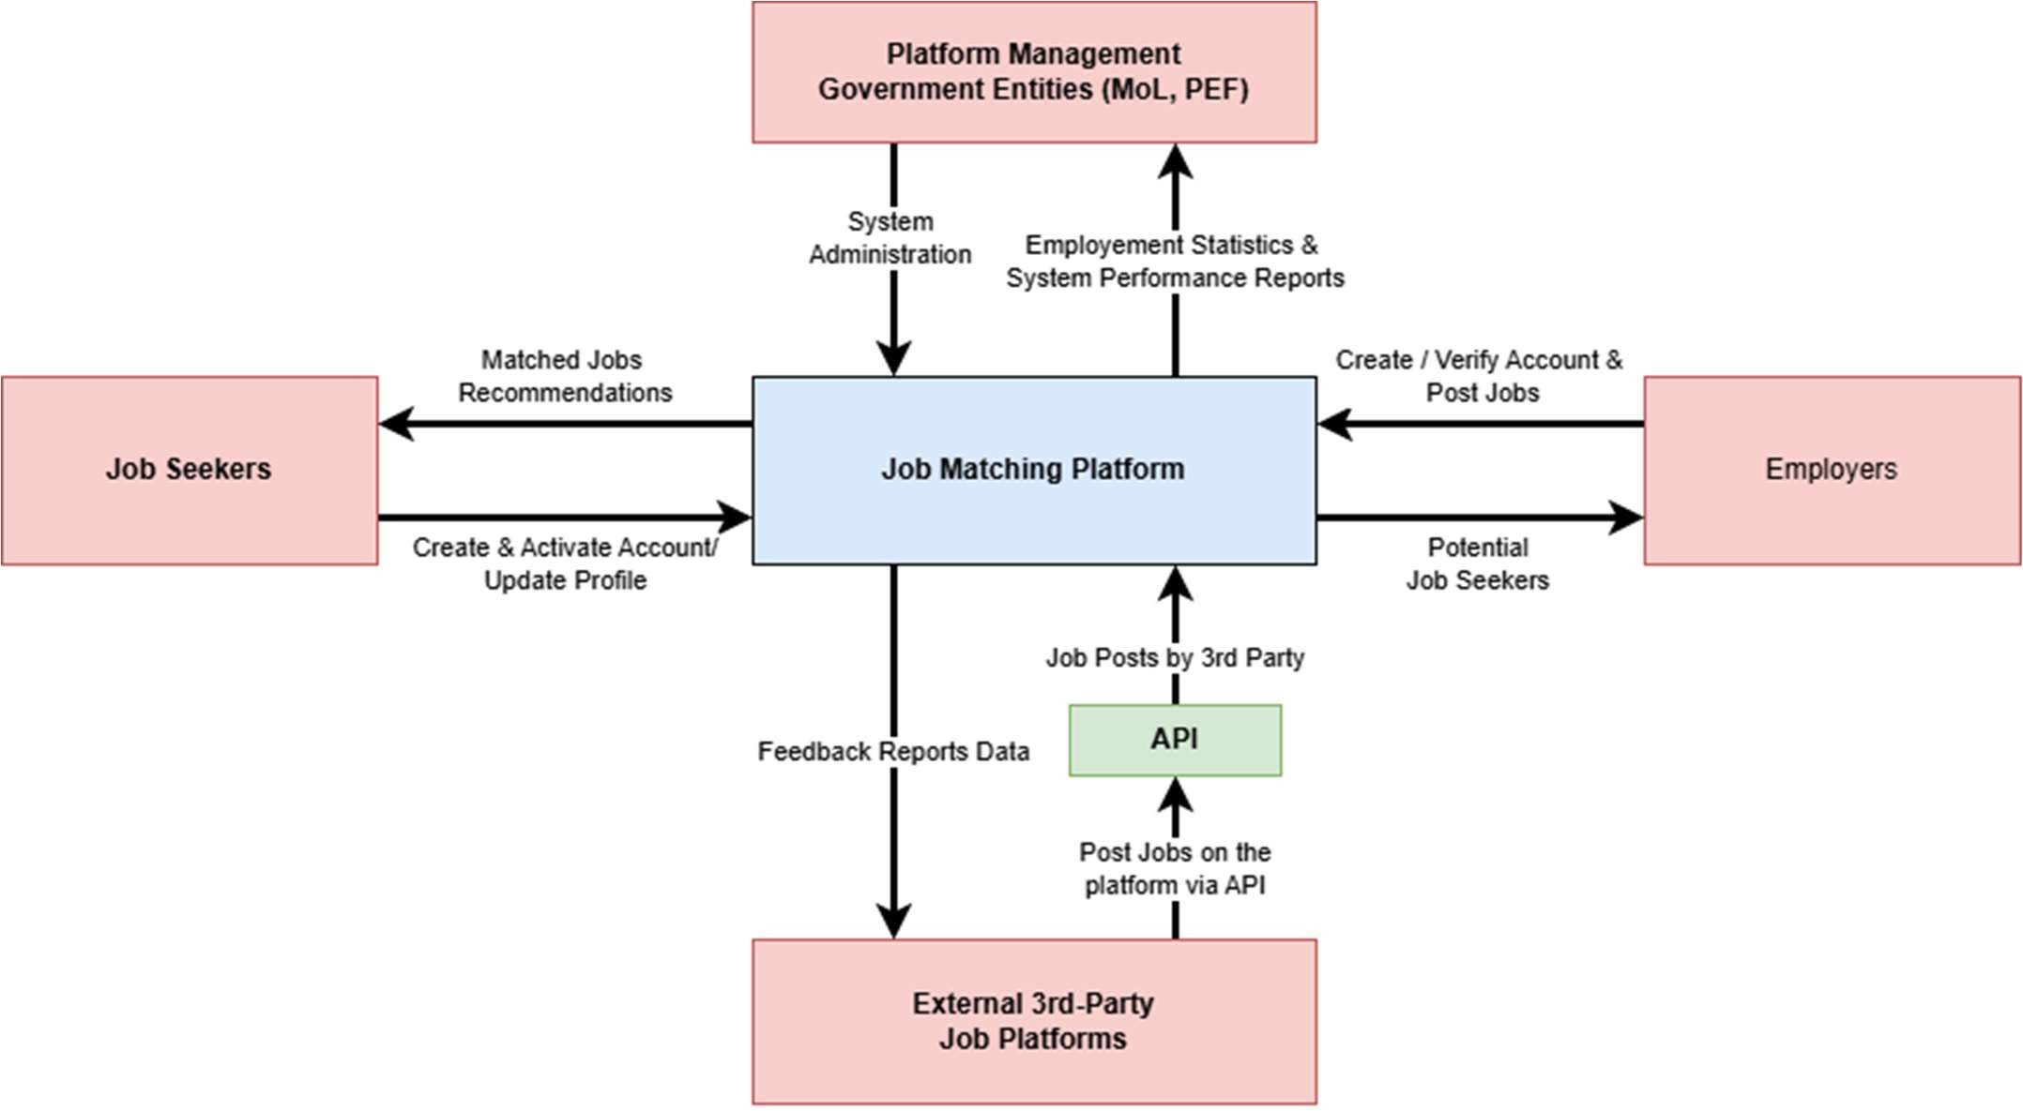System boundaries and external entities (Level 0)
  + Data flows between the system and external entities (Level 1)

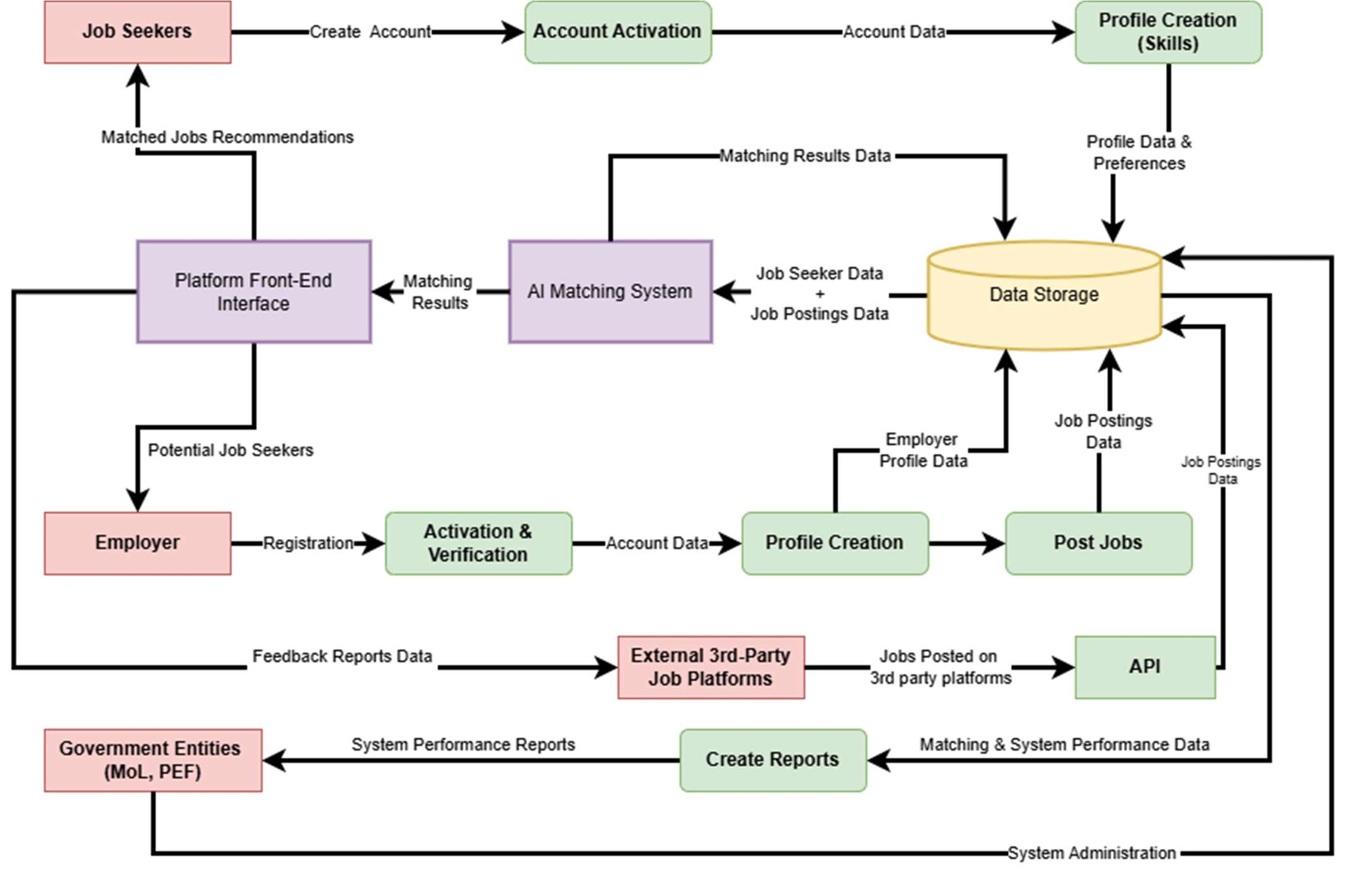

## AI Engine Component Diagram

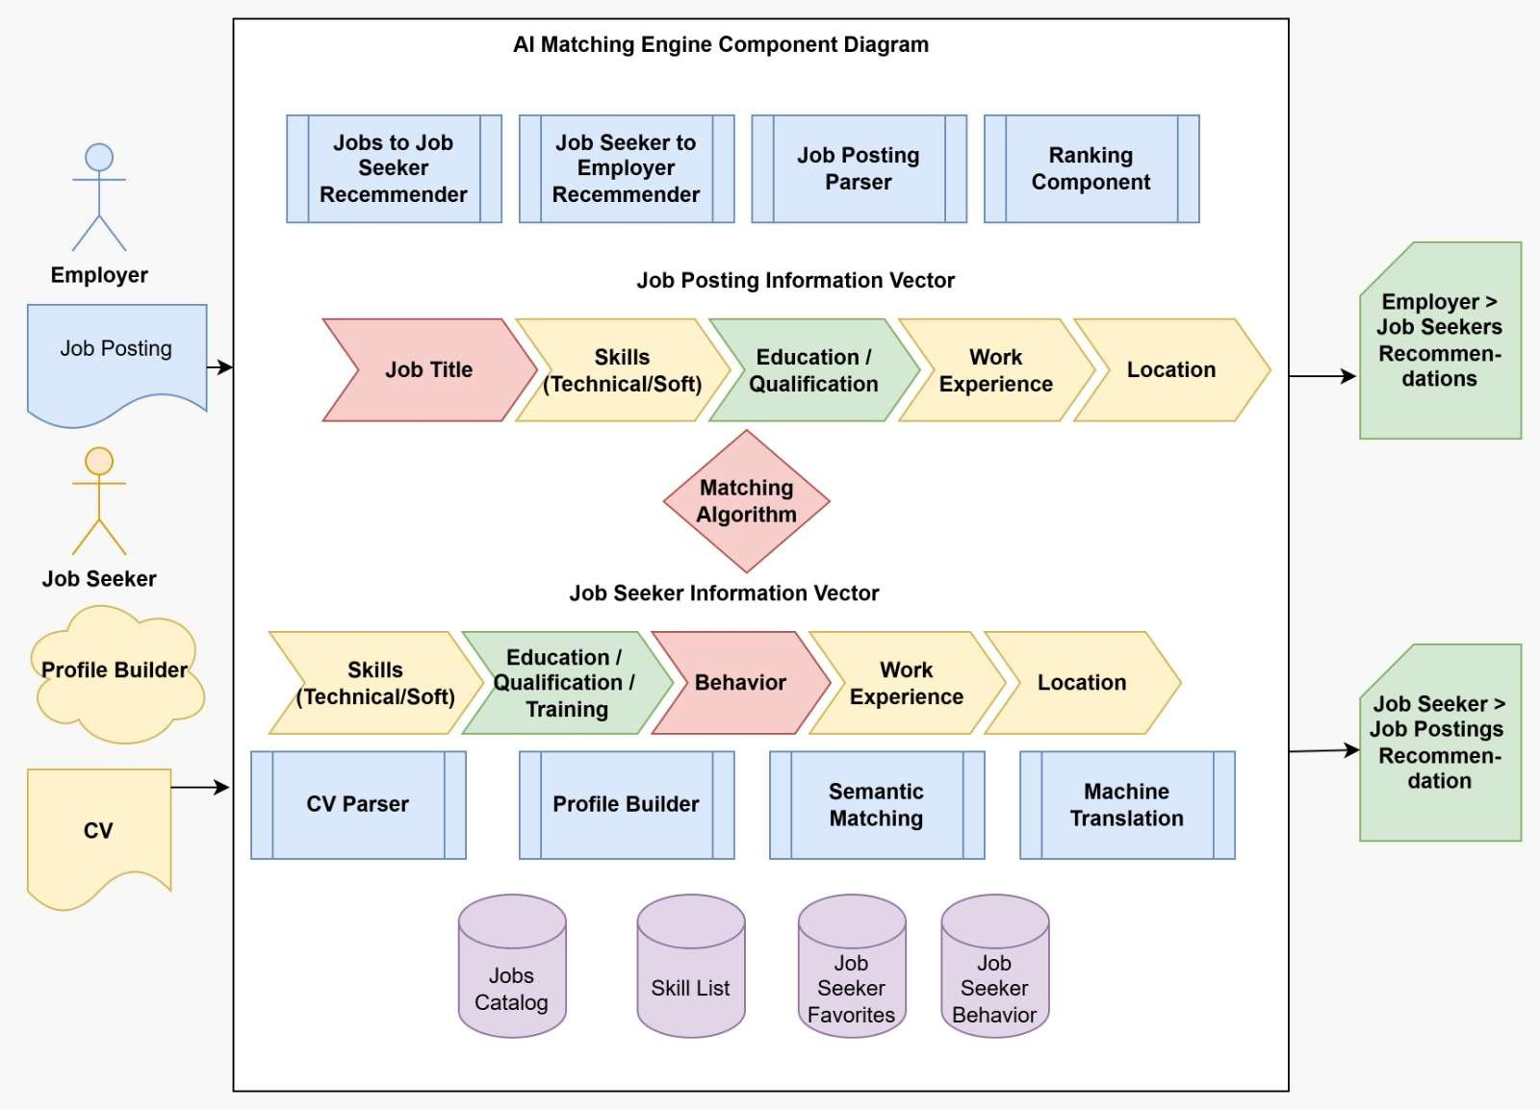

1. **Process Flow Diagrams**
   * Job posting and application process

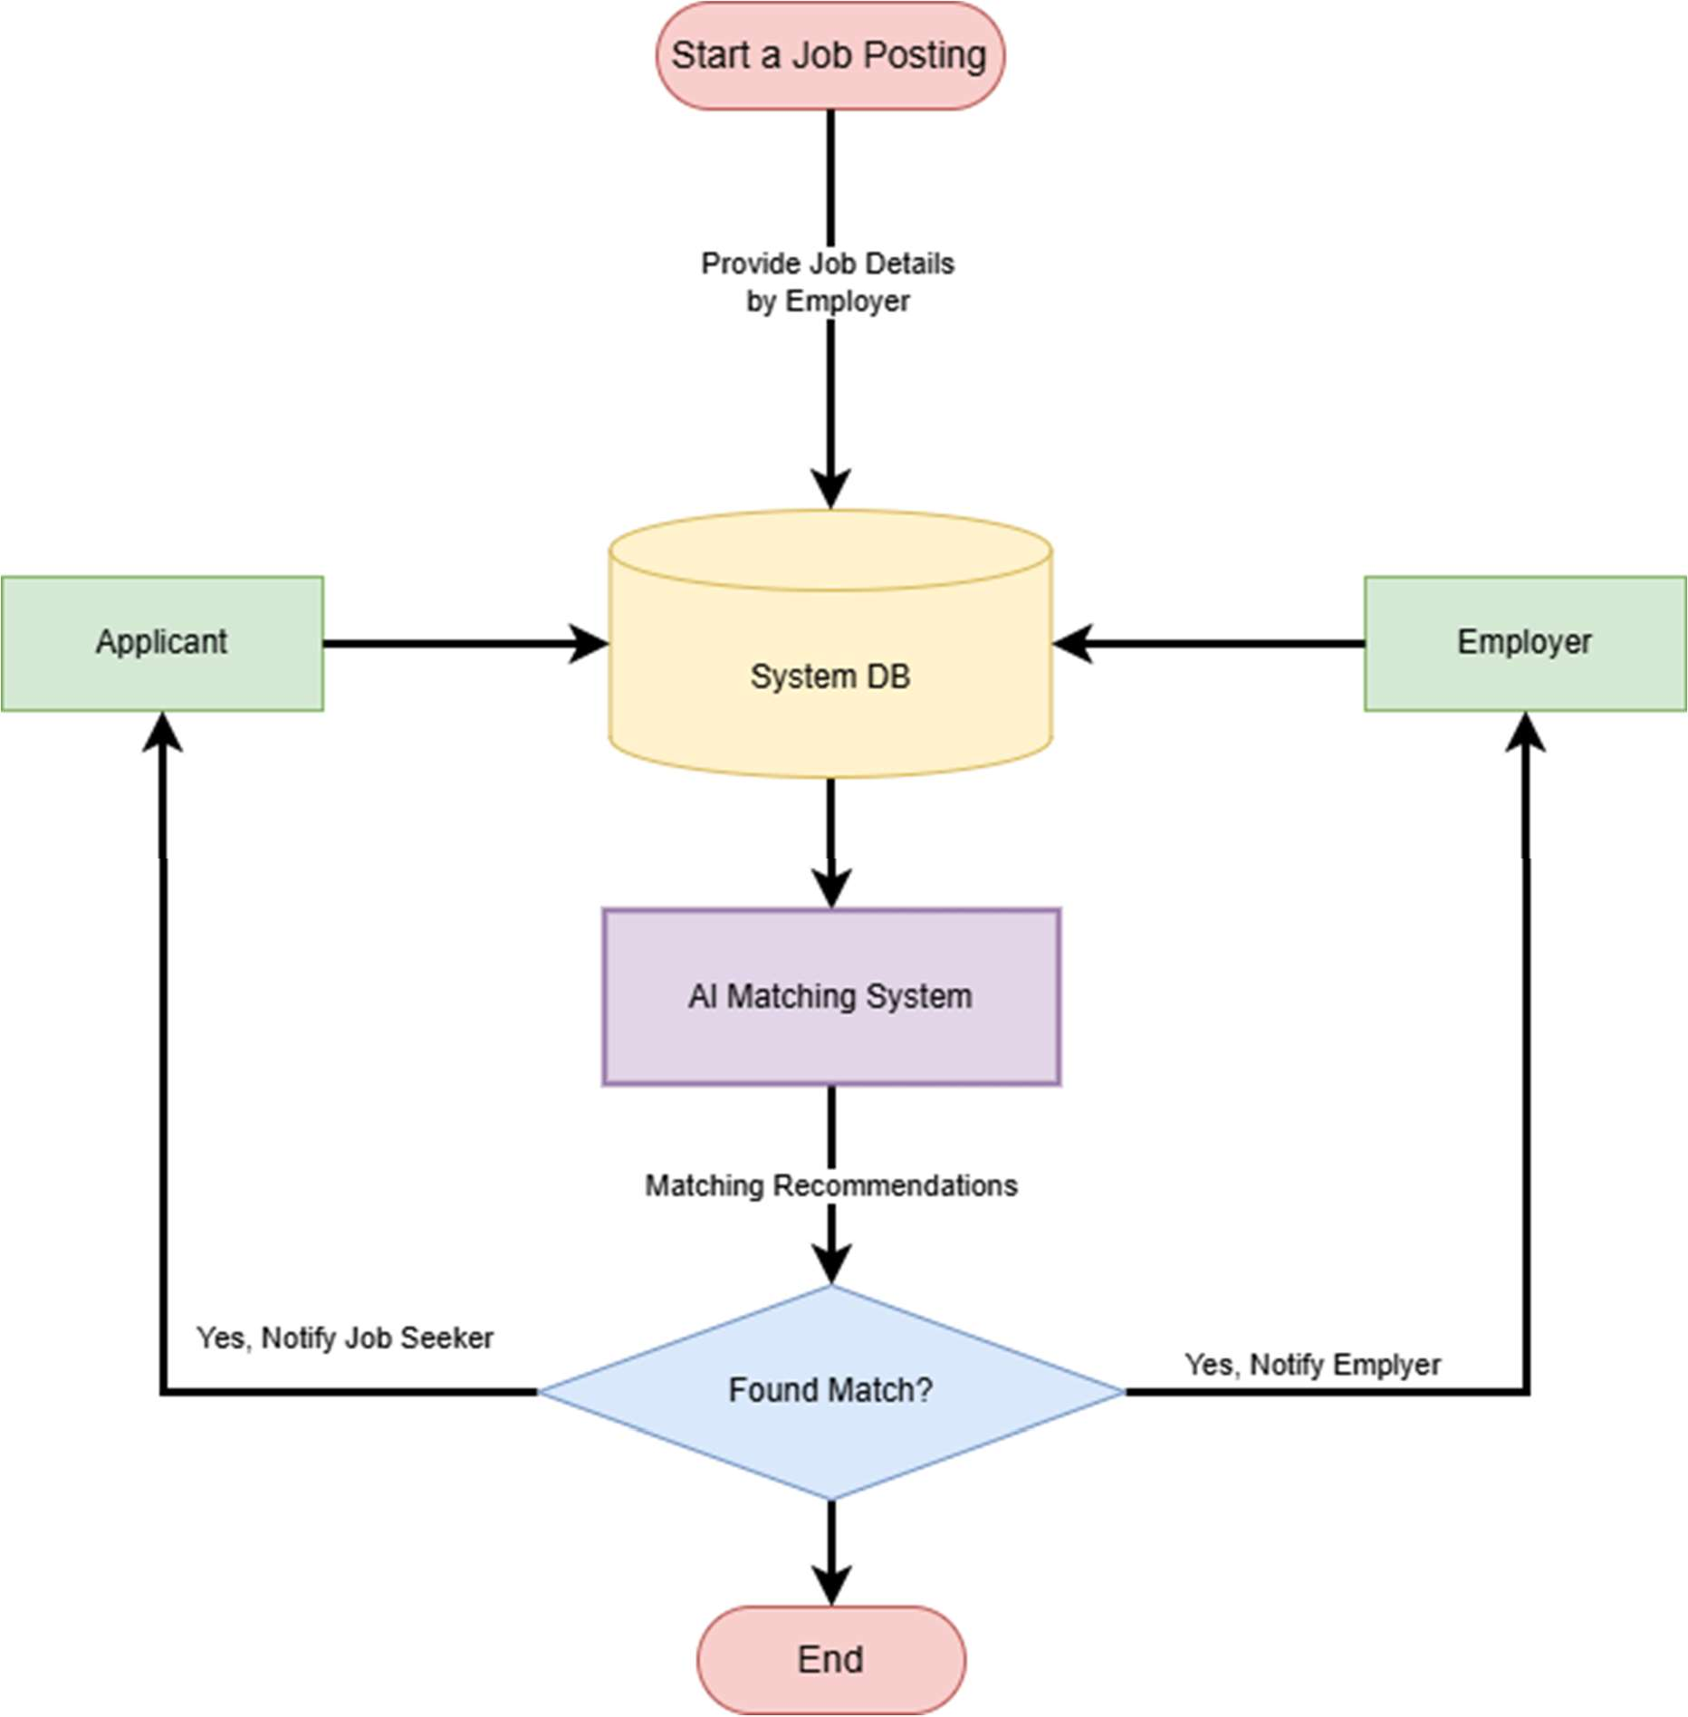

* + User registration and profile management
    - 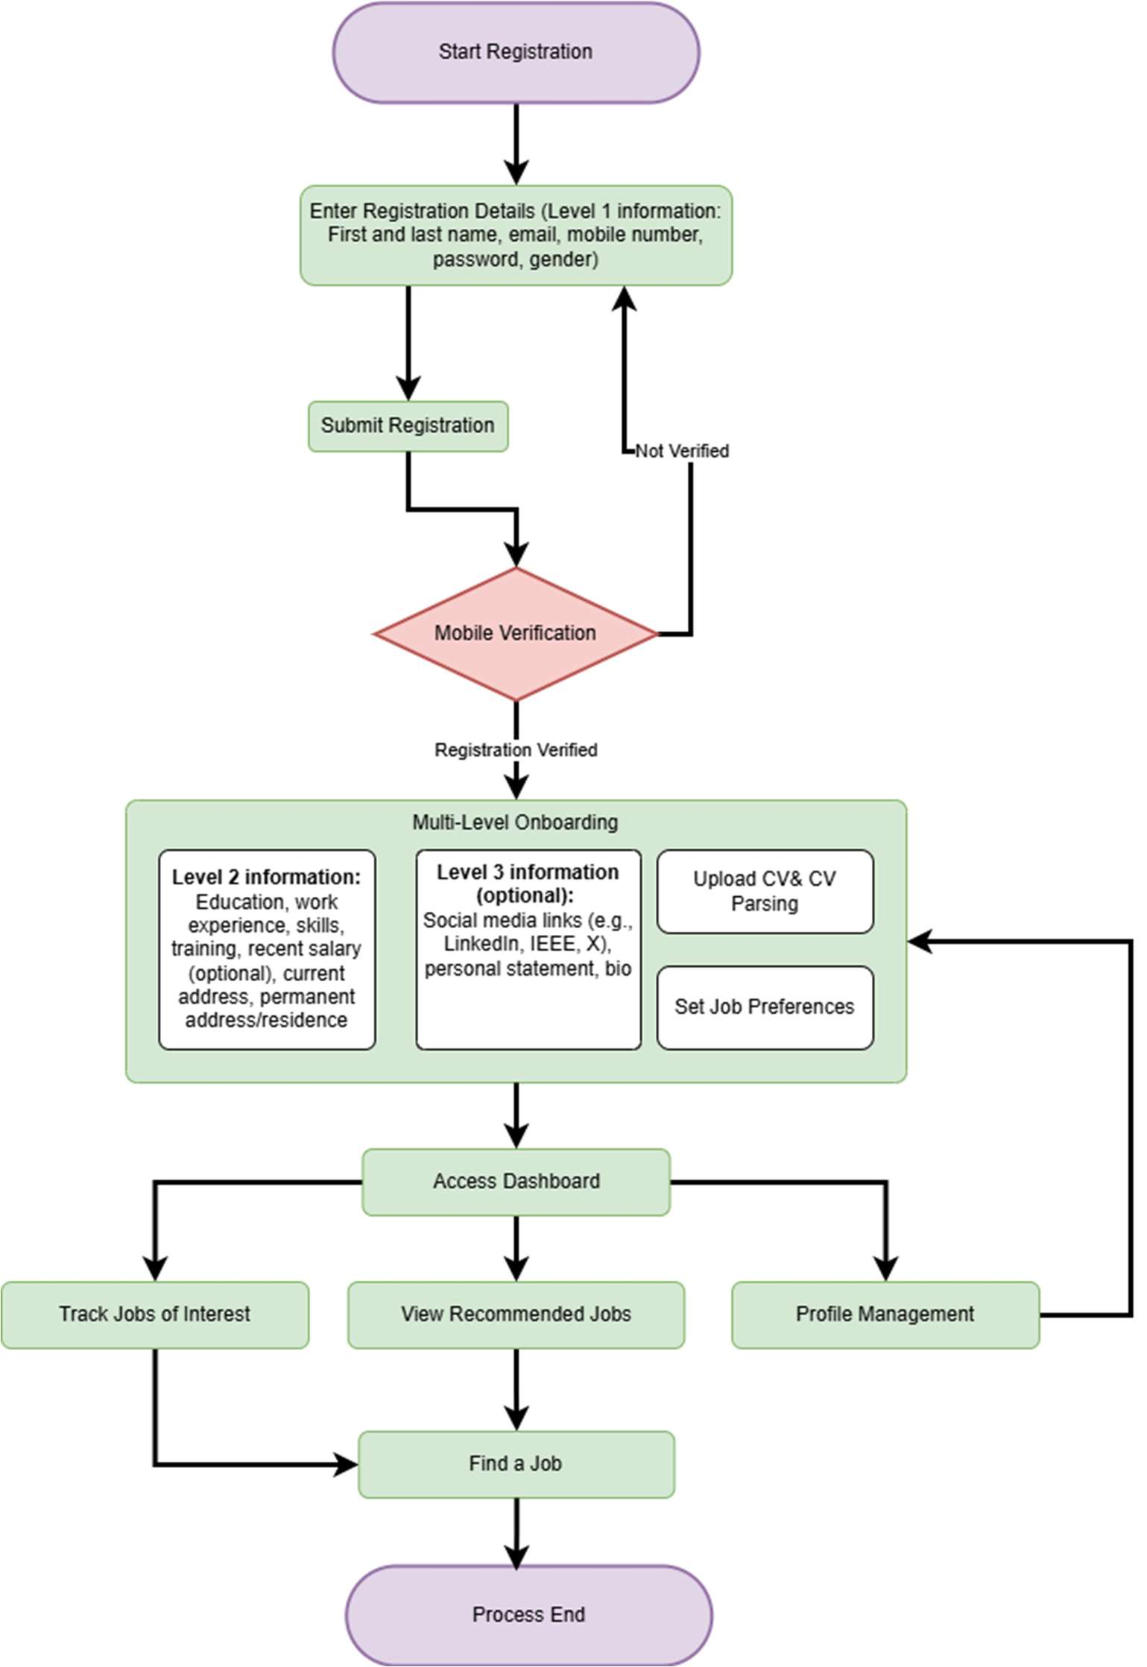Job seeker registration and profile management
    - 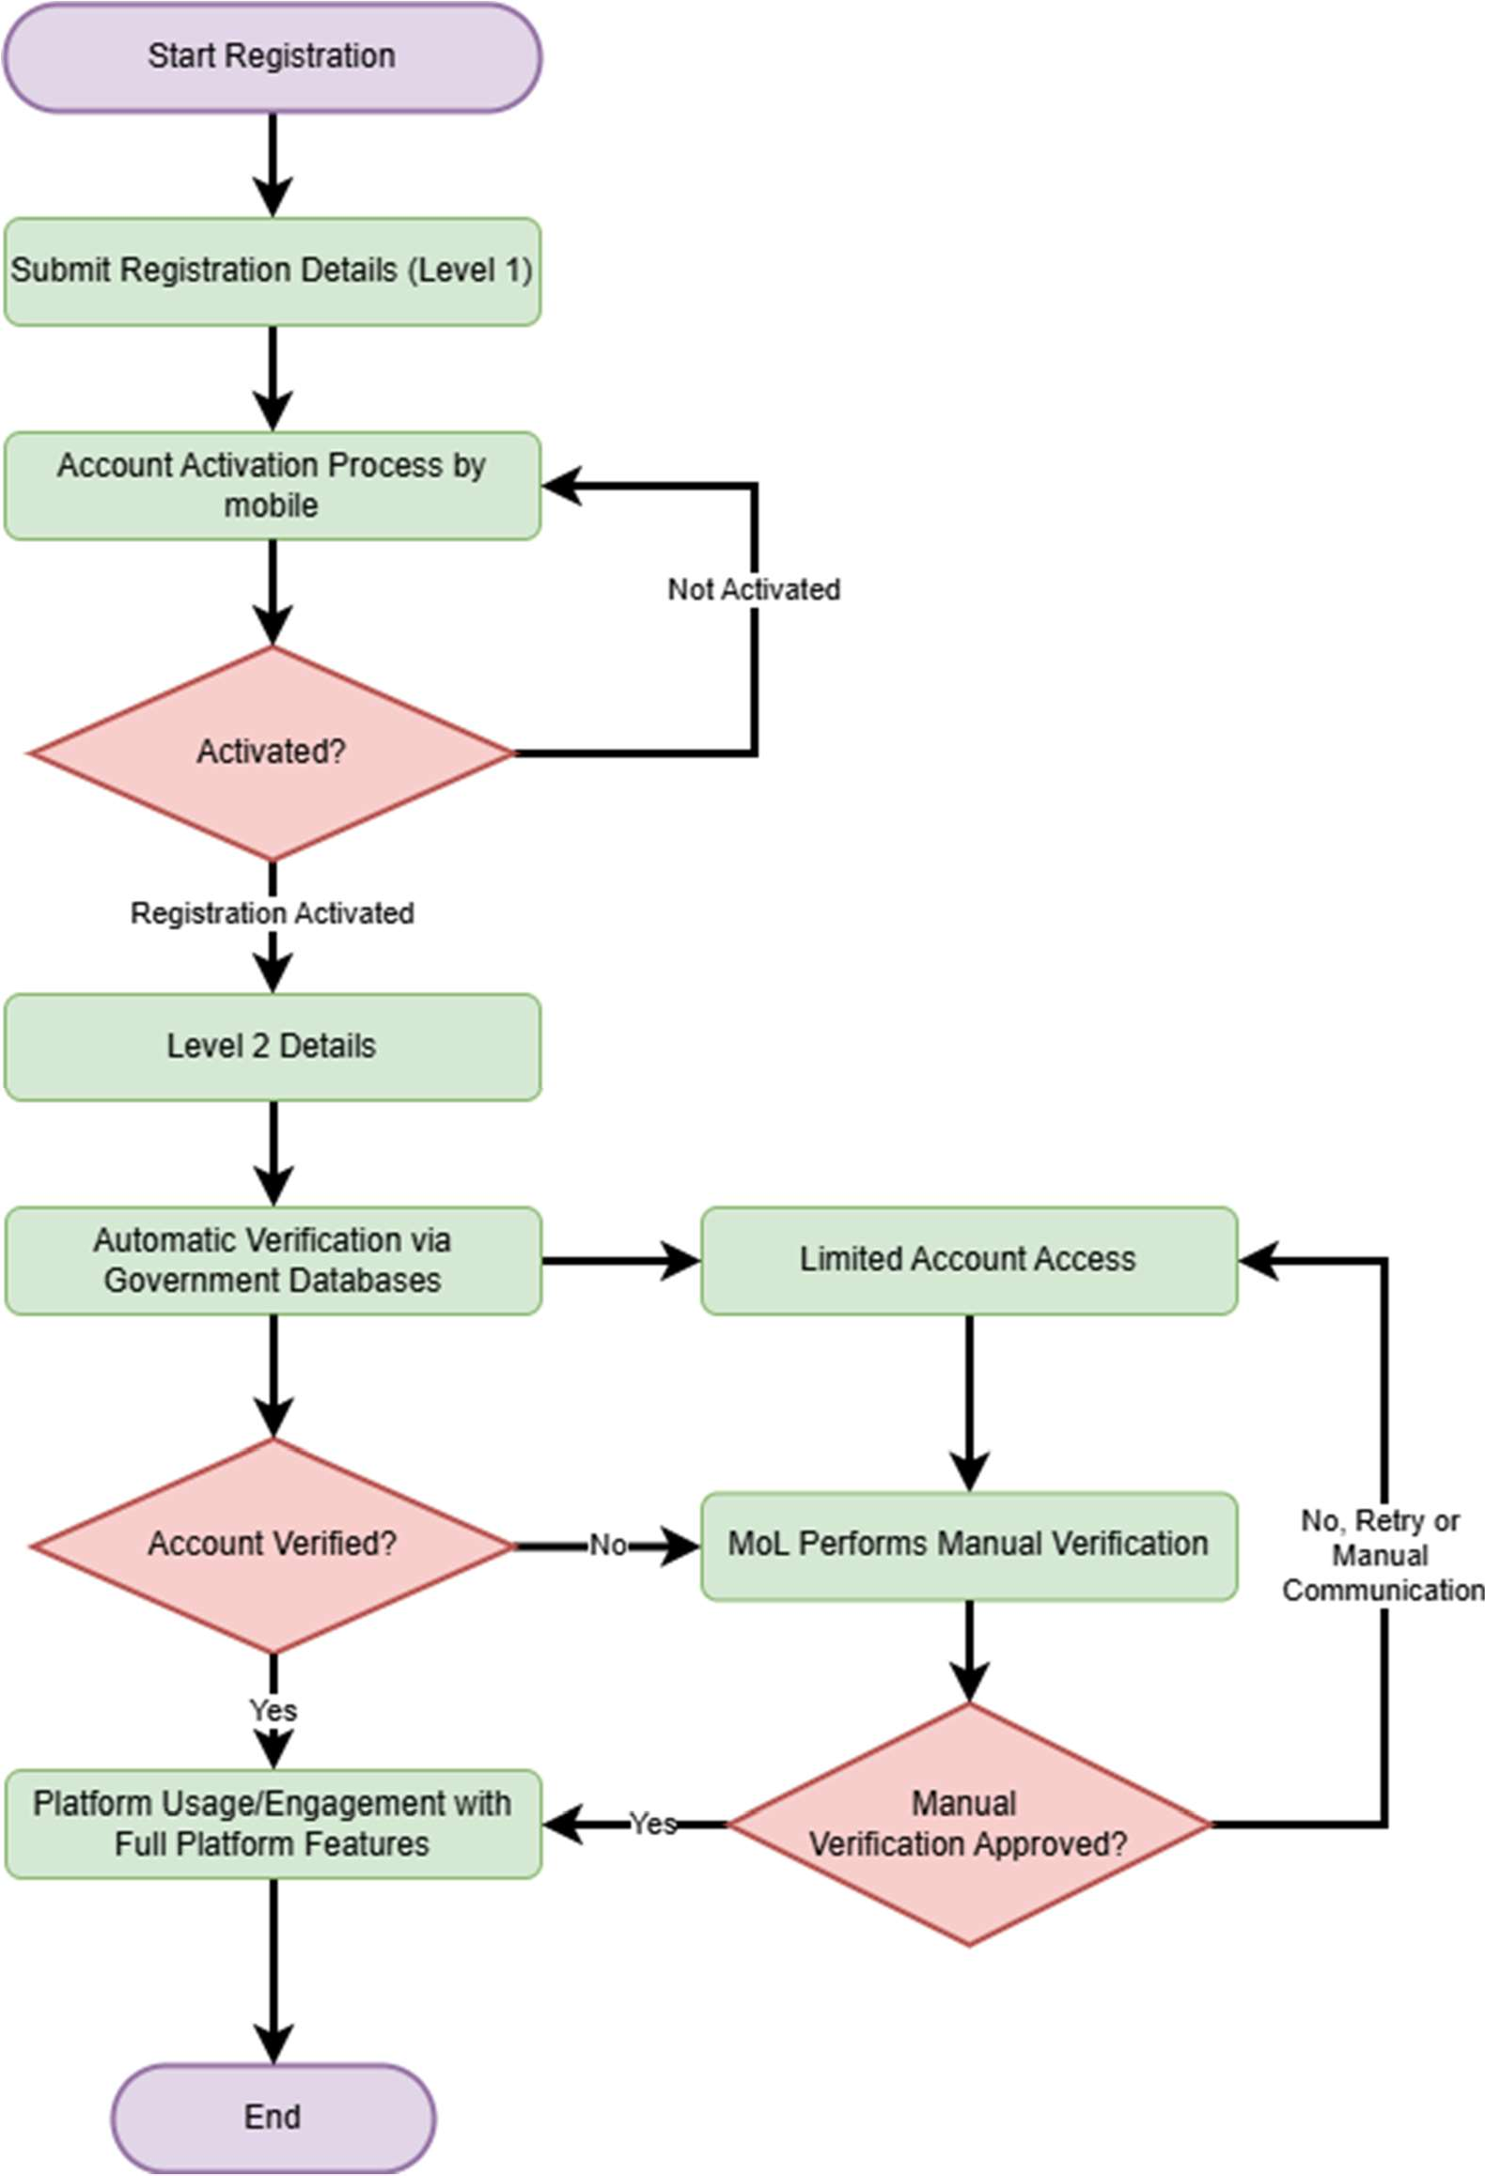Employer registration and profile management
  + 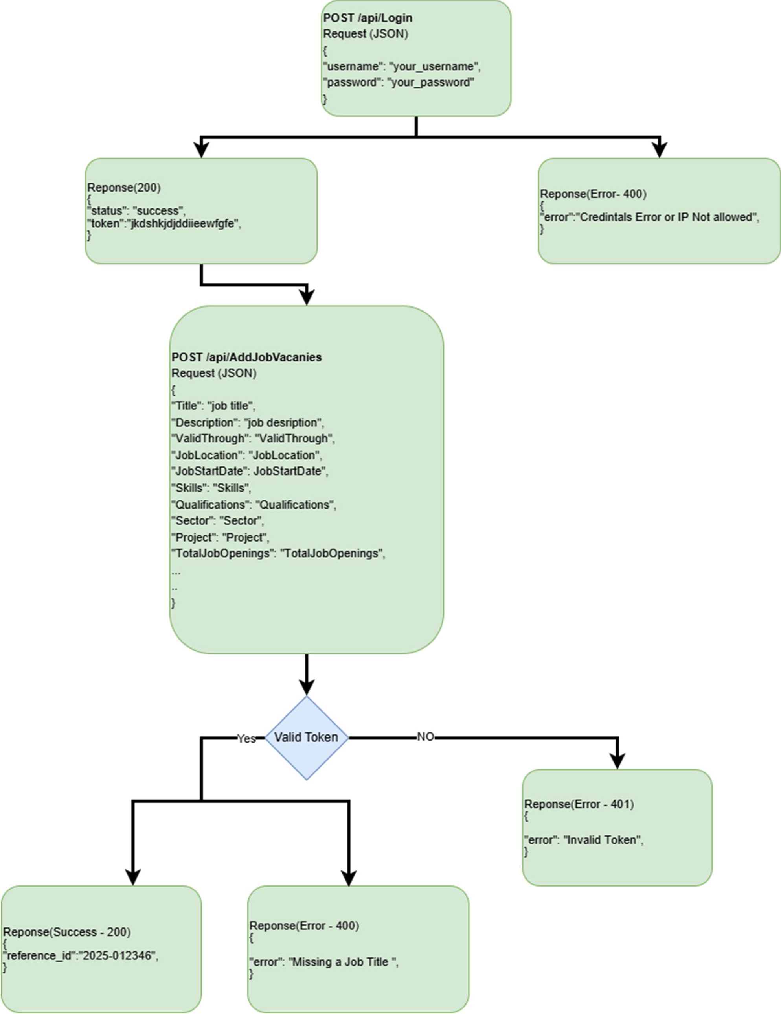Integration with external systems

## Entity Relationship Diagram

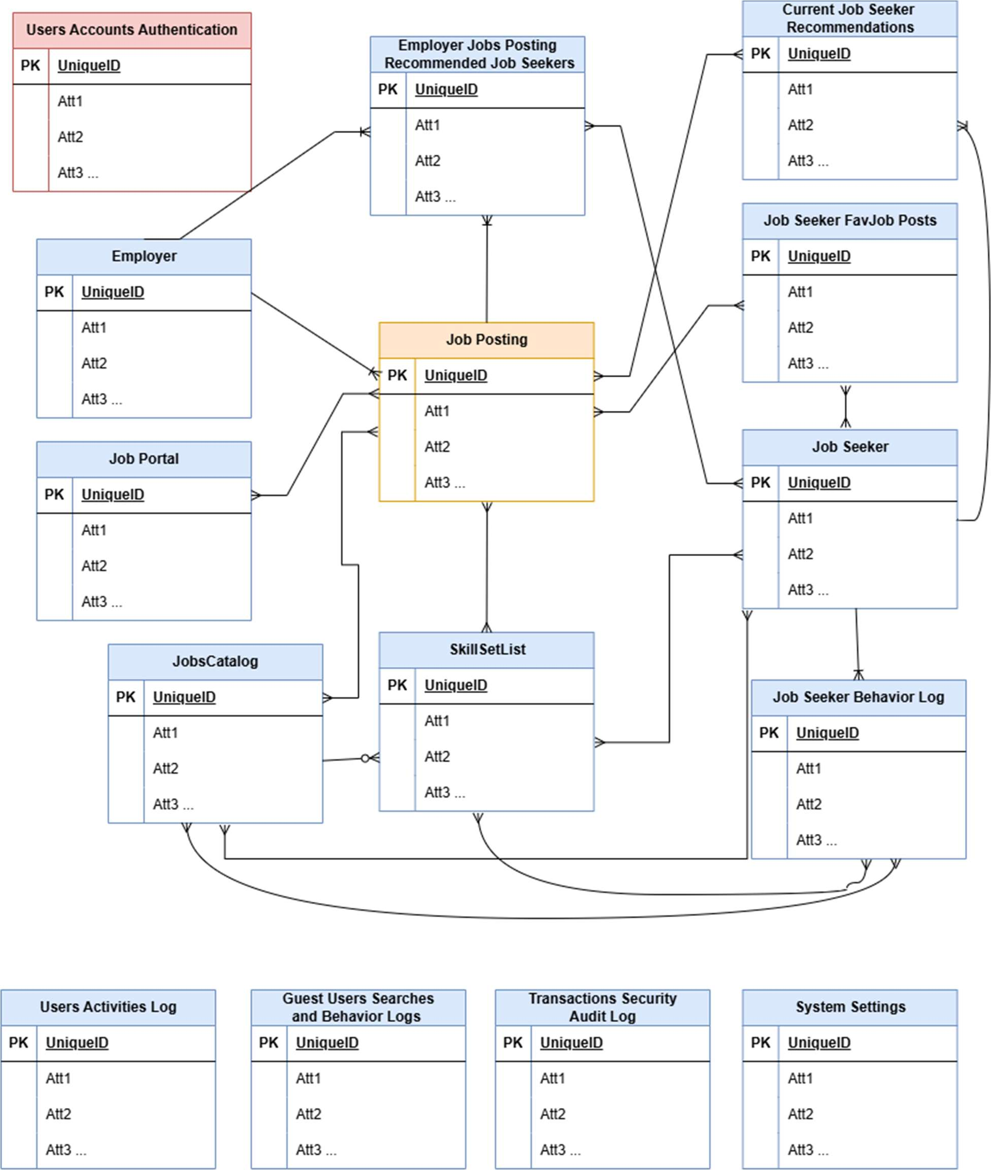

1. **Use Case Diagrams**
   * Key system use-cases:
     + Employers use case diagram

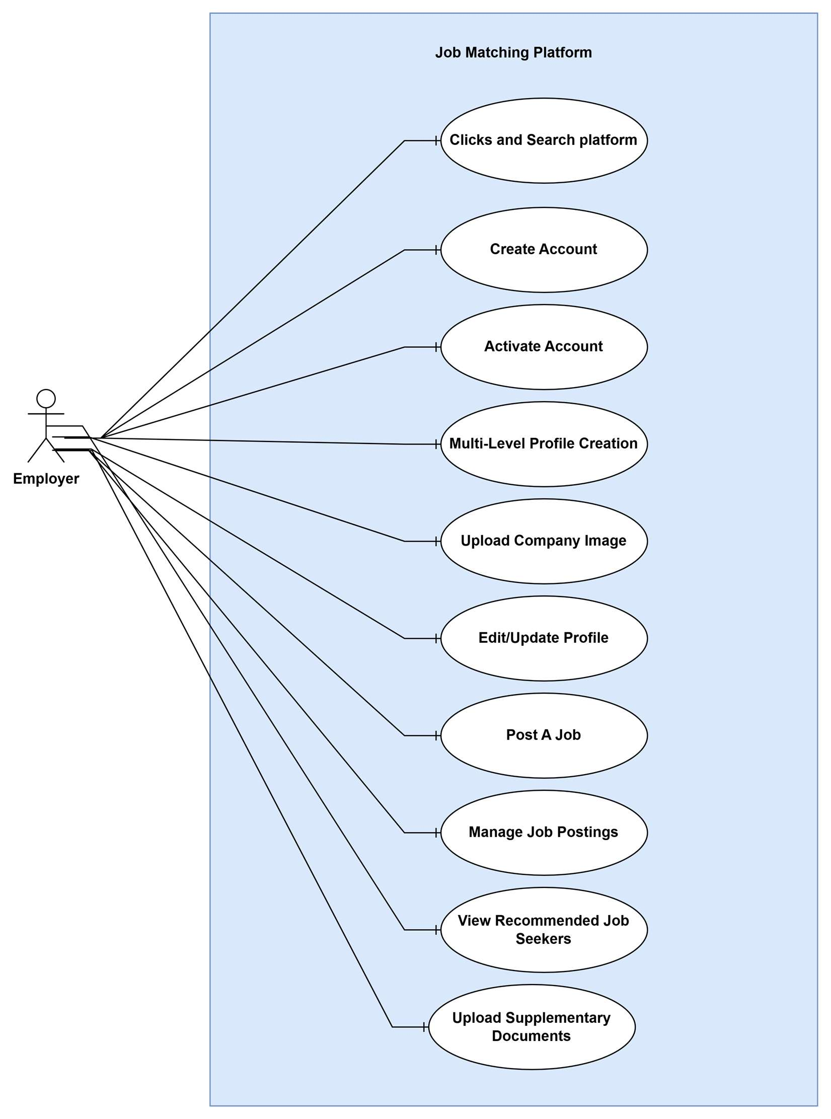

* + - Job seekers use case diagram

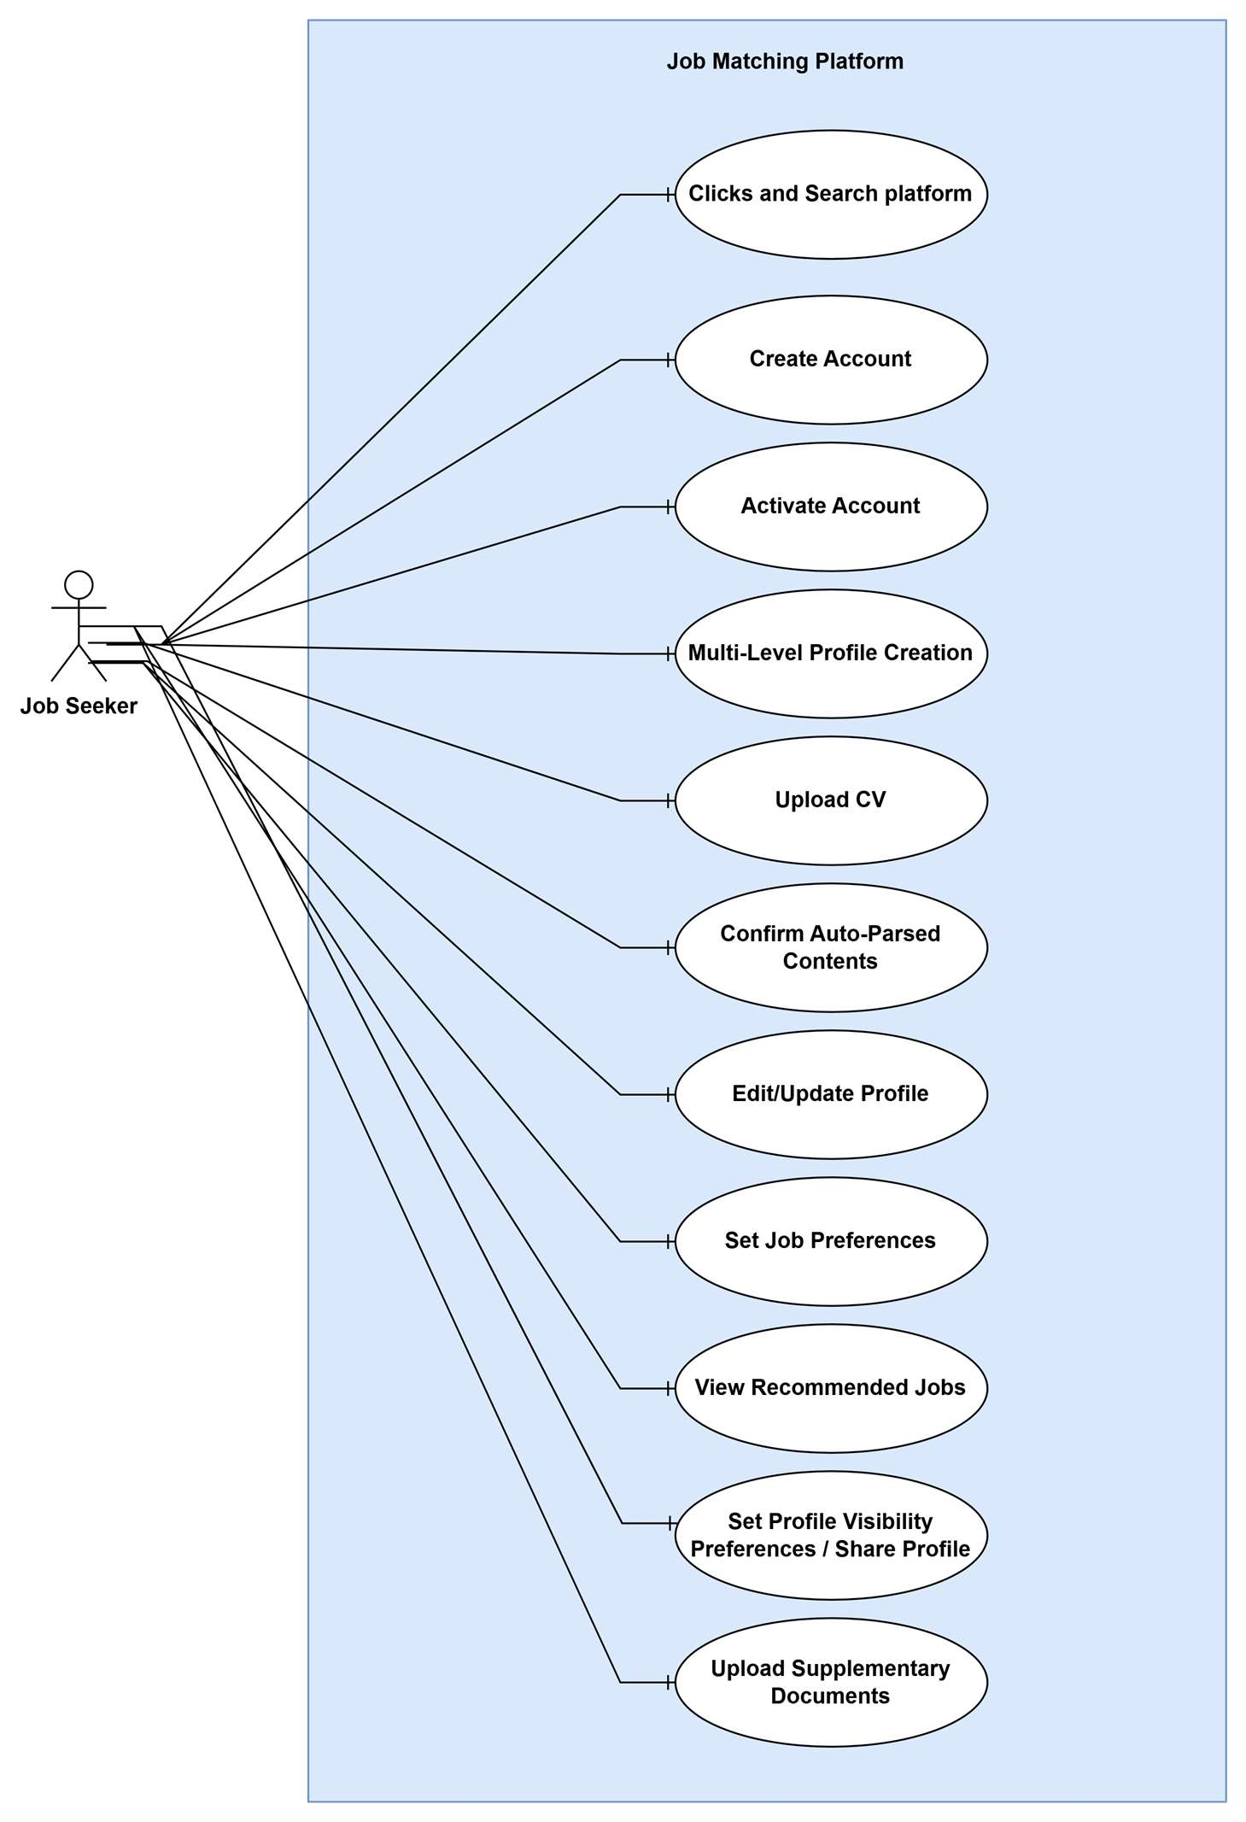

* + - 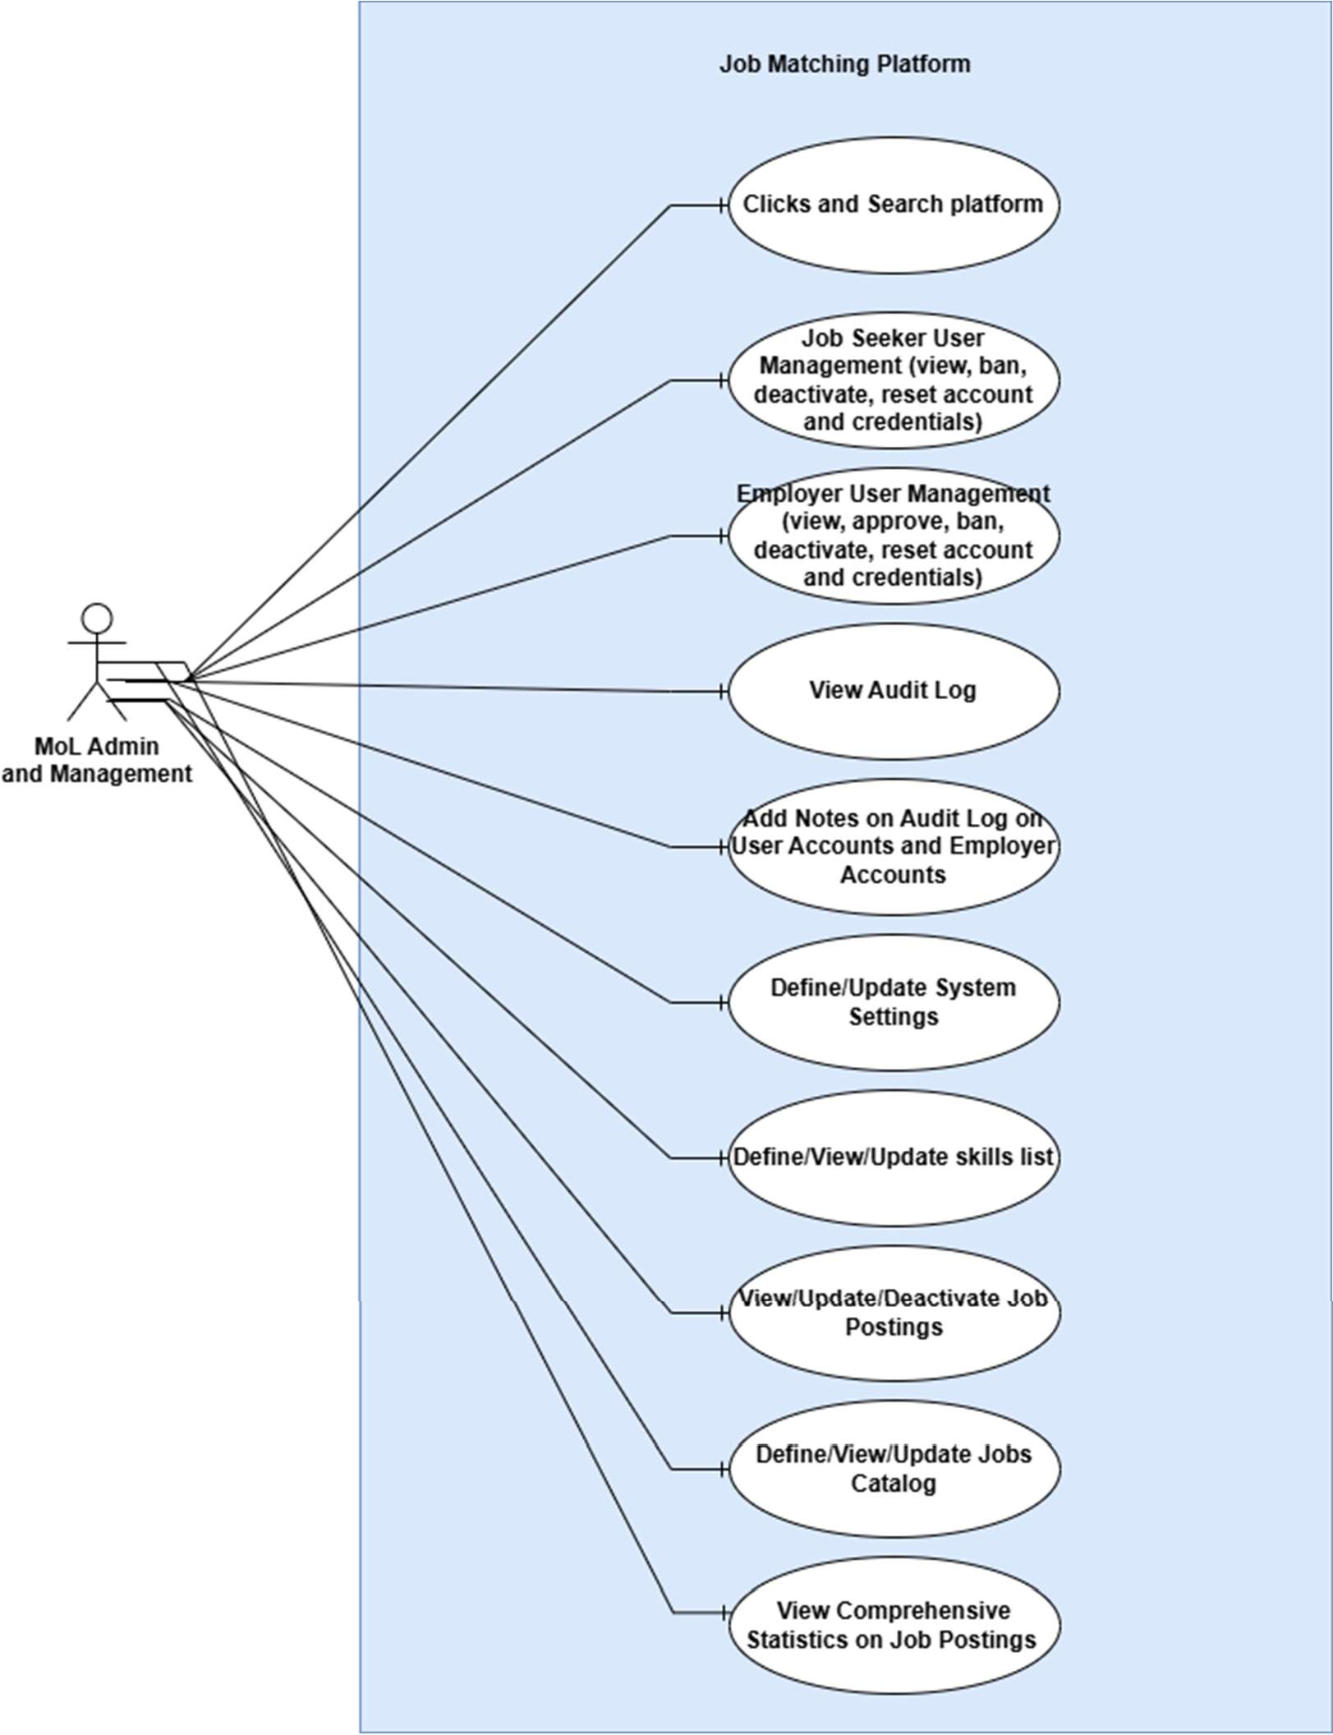MoL Administration Management use case diagram
    - 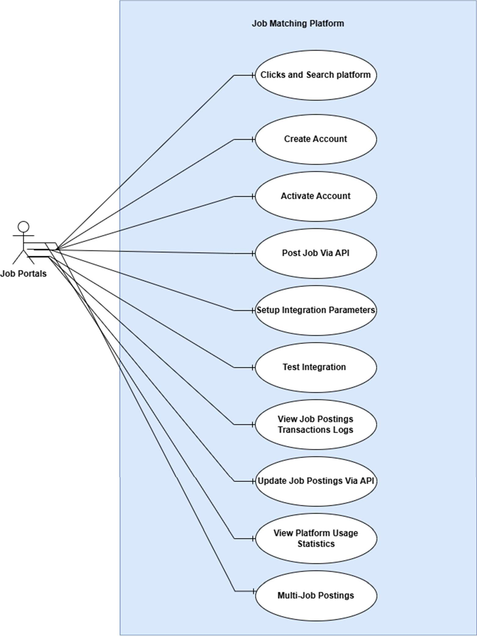Job portals use case diagram

# Appendix B: Issues List

This appendix will track open issues and questions that need to be resolved during the development process:

## Integration Specifications

* + Detailed specifications for the five external job sites to be integrated
  + API documentation and access credentials

## Hosting Decision

* + Final decision on hosting approach (on-premises, cloud, or hybrid)
  + Infrastructure requirements and specifications

## Data Migration Details

* + Detailed inventory of data to be migrated
  + Data quality assessment and cleansing approach

## AI Algorithm Selection

* + Specific algorithms to be used for matching
  + Training data requirements and sources

[Note: This list will be updated throughout the project lifecycle]